FORGET ME NOT

Final Report

____________________________________________________________________________

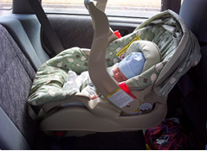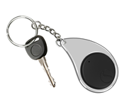

Revision 1

December 2nd, 2019

ECE 497 Capstone Project Group 1

Sponsor: Laura Ochsner

[lauraochsner@hotmail.com](mailto:lauraochsner@hotmail.com)

Group Members: Jacob Cassady

Mason Gardone

Raley Suter

# Table of Contents

Table of Contents 1

1 Introduction and Executive Summary 5

2 System Description 6

2.1 Interfaces 7

2.1.1 External Interfaces 7

2.1.2 Internal Interfaces 8

2.2 System Requirements 8

2.2.1 The system shall survive temperatures up to 175 degrees Fahrenheit. 8

2.2.2 The system shall retain working power for 8 ± 1 days on a single full charge. 8

2.2.3 Key Fob Subsystem shall be no larger than 5.5”x3”x1.5”. 9

2.2.4 Car Seat Subsystem shall be no larger than 5”x5”x2.5”. 9

2.2.5 The system shall be disarmed by pressing the disarm button. 9

2.2.6 Key Fob Subsystem shall make audible sound and vibrations in triggered condition. 9

2.2.7 The system’s alarm sound shall reach 80dB ± 5dB. 9

2.2.8 Alarm shall rearm automatically when user re-enters the perimeter of 30m ± 10m from the car seat subsystem. 9

2.2.9 The system shall alert the operator of low power conditions using an LED indicator and an audible noise. 9

2.2.10 The Key Fob subsystem shall operate with reduced functionality at low power. 9

2.3 Hardware Overview 9

*2.3.1* Microcontroller 10

*2.3.2* GPS Module 10

*2.3.3* RF Telemetry Module 11

*2.3.4* Power Source 11

*2.3.5* Power Estimator Circuit 11

*2.3.6* Printed Circuit Board (PCB) 12

2.3.7 3D Printed Case 12

*2.3.8* Antennas 12

2.3.9 Push Buttons 12

*2.3.10* LEDs 13

2.3.11 Buzzer 13

*2.3.12* Vibration Motor 13

2.4 Software Overview 13

2.4.1 GPS Module Update Thread 14

2.4.2 Telemetry Module Listen Thread 15

2.4.3 Telemetry Module Broadcast Position Thread 16

2.4.4 Car Seat Subsystem 17

2.4.5 Key Fob Subsystem 18

3 Detailed Design 20

3.1 Hardware Detailed Design 20

3.1.1 Batteries 21

3.1.2 XBee Telemetry Module 21

3.1.1 GPS Breakout Board 22

3.1.2 Vibration Motor 22

3.1.3 Buzzer 22

3.1.4 Power Estimation Circuit 23

3.1.5 Pyboard 24

3.1.6 Printed Circuit Board 24

3.1.7 3D Case Design 25

3.2 Software Detailed Design 27

3.2.1 Class Objects 27

3.2.2 Distance Calculation 32

4 Test Procedures and Results 32

4.1 Test Procedures 32

4.1.1 Temperature Test 32

4.1.2 Longevity Test 32

4.1.3 Sizing Test 32

4.1.4 Alarm Disarm Test 33

4.1.5 Sound Test 33

4.1.6 Rearm Test 33

4.1.7 Low Power Test 33

4.2 Test Results 34

4.2.1 Temperature Test 34

4.2.2 Longevity Test 34

4.2.3 Sizing Test 34

4.2.4 Alarm Disarm Test 34

4.2.5 Sound Test 35

4.2.6 Rearm Test 35

4.2.7 Low Power Test 35

4.3 Requirements Traceability 35

5 Conclusions 36

6 Recommendations for Future Work 37

6.1 Software Future Recommendations 37

6.2 Hardware Future Recommendations 38

7 References 38

8 Appendices 38

8.1 APPENDIX A:Sponsor/Team Contact Information 38

8.2 APPENDIX B: Data Sheet Links 39

8.2.1 Telemetry Module 39

8.2.2 GPS Module 39

8.2.3 PyBoardv1.1 39

8.2.4 Power Source 39

8.2.5 Power Estimation Circuit 40

8.2.6 Sixfab Internal Active GPS Patch Antenna 40

8.2.7 W24P-U OEM Wi-Fi Antenna 40

8.2.8 Coin Vibration Motor 40

8.2.9 Piezoelectric Buzzer PKB24SPCH3601-B0 40

8.3 APPENDIX C: Diagrams and Pictures 41

8.4 APPENDIX D: Simulation Results 44

8.5 APPENDIX E: Software installation instructions 45

8.5.1 Solidworks 45

8.5.2 Cura 45

8.5.3 XCTU 45

8.5.4 KiCAD 45

8.5.5 PuTTY 46

8.6 APPENDIX F: User's Manuals 46

8.6.1 General use 46

8.7 APPENDIX G: Purchase Orders 47

8.8 APPENDIX H: Material Documentation and Reconciliation 50

8.8.1 Single Product Parts 52

8.8.2 Overhead Parts List: 56

8.9 APPENDIX I: SolidWorks Drawings 57

# Introduction and Executive Summary

According to the National Safety Council, there are an average of 38 child vehicular deaths annually in the United States. More than half of these are caused by heat stroke, the result of parents forgetting their child in a vehicle. According to Dr. David Dimond, a professor of psychology at the University of South Florida, this tragedy is most often the work of a part of the brain called the basal ganglia which allows people to perform easy or routine tasks on ‘autopilot’ without any conscious effort. The Forget Me Not Child Safety System is a device designed to make checking for a child when exiting a vehicle habit so that it becomes part of the routine in which we sometimes fall without thinking. However, routine alone is not enough to rely upon when regarding the lives of children, therefore the Forget Me Not will also remind caretakers of the child in the case that habit fails. Our sponsor has read and watched tragic news stories reporting these deaths and had the idea for a product that could potentially eliminate this statistic. The requirements for this iteration of the design were to reduce the size of the previously built system, add a vibration component to the alarm, make the existing alarm louder, add GPS capabilities, program the system to rearm automatically, and add a low battery alarm. These requirements came in addition to the functionality that already existed from the previous iteration of Forget Me Not.

The effort to reduce the footprint of the system made it impossible to reuse any parts in the previous iteration of the design, and because all the hardware was changing, new software had to be built up from scratch to match. Part selection with an emphasis on footprint size was performed and parts were ordered. Once a bill of materials was put together, a schematic was created, and a PCB layout designed and ordered. SolidWorks was then used to create 3D case designs to contain the PCBs and all the mounted components. These cases were printed using a 3D printer, modified, and printed again. Lastly, software was written for the internal and external interfaces of the system to match the functionality of the previous iteration and include the new functions requested.

Once the system was fully complete, tests were performed to verify most desired qualities of the system. These tests included connecting the system to a lab bench DC power supply to simulate a low power condition, providing and removing power to simulate loss of RF connection, and walking through the parking lot to verify the GPS capability. The volume of the Key Fob system was reduced by 80% and the car seat by 70%. The size requirements for this iteration of the design were met. The low power alarm, automatic rearming, vibration, and volume were also met. Neither the temperature requirement nor the power requirements were tested, but the power requirement was not met because the current draw was too high for the selected batteries on the key fob subsystem.

# System Description

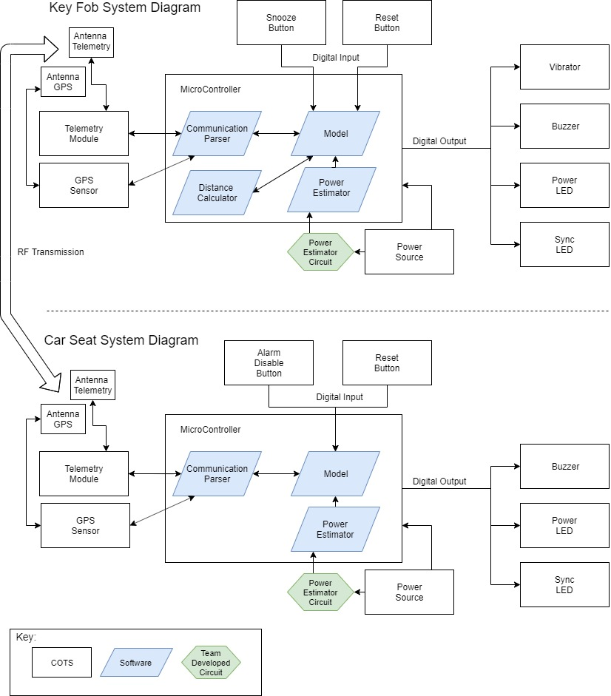

Figure 1: System Diagram

The Forget Me Not Child Safety Device is made of two subsystems; one of which is placed in the car near the child and the other is carried/held by the user. These two subsystems are defined as the car seat and key fob subsystems, respectively. As the two subsystems move away from each other, an alarm will sound unless the car seat system was previously disarmed.  Both devices are controlled by a pyboard microcontroller. The subsystems communicate using radio frequency (RF) telemetry. The subsystems contain global positioning system (GPS) modules to calculate the distance between subsystems. Each subsystem also contains two push buttons and four different light emitting diodes (LED), which are all mounted found on the pyboard. The subsystems are also powered by batteries to make the systems portable. The subsystems also each have a custom 3D case and printed circuit board (PCB). Refer to **Figure 1** for more information.

## Interfaces

### External Interfaces

#### Push Buttons

##### **Disarm Button**

The disarm push button is present only on the car seat subsystem. When pressed by the user, a digital signal will activate the Power light emitting diode (LED) to indicate the subsystem has power. When the disarm button is pressed and the two subsystems are in range and connected, a digital signal to the microcontroller will disarm the audible and vibration alarms on the key fob subsystem.

##### **Reset Button**

The reset push button is on both subsystems. When this button is pressed, a digital signal is sent to the microcontroller. The subsystem will reset to the starting state in the program. This starting state is different for each subsystem.

##### **Snooze Button**

The snooze push button is present solely on the key fob subsystem. When pressed, the snooze push button will send a digital signal to the microcontroller to silence the alarm for 2 minutes ± 10 seconds.

#### GPS Communication

The GPS chip on each subsystem will be used to measure the location of each subsystem. The GPS chip will use an external antenna to broadcast information.

#### Antennas

The antennas will be attached inside both subsystems’ chassis. The antennas will be receiving and transmitting information via radio waves. The GPS and RF telemetry chips will use different antennas.

#### LEDs

##### **Power LED**

This LED will be used to display information about power. The microcontroller sends a digital signal at a set duty cycle to make the LED blink or not blink.

##### **Reset LED**

The reset LED will flash when the system is reset. The LEDs that flash will be controlled by the microcontroller.

#### Power Source

The power source is a compact battery mounted inside the subsystem. Each subsystem will require a user to replace the batteries when power is low.

#### Vibration Motor

The vibration motor will be mechanically attached to the 3D casing of the key fob subsystem. When the microcontroller activates the alarm function the vibration motor will turn and begin vibrating the subsystem.

### Internal Interfaces

#### Digital Outputs

Digital outputs are the data from the microcontroller to the LEDs, buzzer, vibration motor, GPS module, and RF telemetry module. The microcontroller will control the LEDs, the buzzer, and the vibration motor by sending a logic high to a switching device, allowing each of these end items to receive power. The GPS and RF integrated circuits (IC) will be sent data from the microcontroller using UART (Universal Asynchronous Receiver/Transmitter) and Rx/Tx connections.

#### Digital Inputs

The user will cause an input to the microcontroller to start a task via the on-board push buttons. The GPS and Telemetry ICs will send digital data via UART to the microcontroller.

#### Antenna to GPS and RF ICs

Signals received by the antenna will be directed to the GPS or RF telemetry modules. Each subsystem will have an antenna dedicated to the GPS module and an antenna dedicated to the RF telemetry module.

#### Power Source Connections

The power source will supply voltage to the microcontroller which supplies power to drive the other components. The power source feeds into the power estimation circuit through a high-side-driver-circuit which then feeds into an analog-to-digital converter (ADC) on the microcontroller.

## System Requirements

### The system shall survive temperatures up to 175 degrees Fahrenheit.

The Forget Me Not system is likely to endure high heat situations when kept inside a car.  To account for this, the system must be tested to operate when exposed to temperatures 175 degrees Fahrenheit (80) and below.

### The system shall retain working power for 8 ± 1 days on a single full charge.

The Forget Me Not system shall operate for several days of use. If the user is required to frequently change batteries on both subsystems, the benefit of the Forget Me Not system is greatly compromised.  Both subsystems must remain operating after 8 ± 1 days of intermittent use.

### Key Fob Subsystem shall be no larger than 5.5”x3”x1.5”.

It is required that the key fob subsystem be designed such that it will fit on a keychain.  The subsystem must be designed to be no larger than 5.5” in width, 3” in length, and 1.5” in thickness.

### Car Seat Subsystem shall be no larger than 5”x5”x2.5”.

It is required that the car seat subsystem be designed for storage in or under a car seat.  The subsystem must be designed to be no larger than 5” in width, 5” in length, and 2.5” in thickness.

### The system shall be disarmed by pressing the disarm button.

The system shall enter the disarmed state when the disarm button is pressed.  This button is located on the car seat subsystem. The disarm button shall disarm the system as long as a communication connection is available with the key fob subsystem.

### Key Fob Subsystem shall make audible sound and vibrations in triggered condition.

The key fob shall alarm the operator if they leave a 30m ± 10m perimeter around the car seat subsystem before disarming the system.  This alarming will be performed with both sound and vibration.

### The system’s alarm sound shall reach 80dB ± 5dB.

The system must create an alarm sound that is both audible and non-damaging to the ears of any user.  This value was chosen because 80dB ± 5dB is the threshold at which damage starts to occur to hearing.

### Alarm shall rearm automatically when user re-enters the perimeter of 30m ± 10m from the car seat subsystem.

The system shall enter the alarm state upon re-entry of the key fob into the alarm boundary. This is to ensure repeated working use of the system with no required user input outside of pairing the two subsystems and replacing batteries. This requirement can be validated by disarming the system, leaving the boundary, re-entering the boundary, and then leaving the boundary again.  If this requirement is met, the alarm will sound.

### The system shall alert the operator of low power conditions using an LED indicator and an audible noise.

It is critical that the end-user be informed when the power for the system is almost depleted. This information is supplied to the user audibly and visually using a buzzer and an LED.

### The Key Fob subsystem shall operate with reduced functionality at low power.

In the case of the key fob subsystem reaching a low power condition, it must turn off all power consuming systems except supply to the low power indicators described above in section 1.2.9. This is to extend battery life to increase the likelihood of the user noticing the low power condition.

## Hardware Overview

The two subsystems of the Forget me not system both have the following components: a microcontroller, GPS breakout module, RF telemetry module, two antennas, two push buttons, LEDs, a buzzer, and a power estimator circuit. The Key fob subsystem has a custom printed circuit boards (PCB) and 3D printed case, and one vibration motor. The Car Seat subsystem also has a custom printed circuit boards (PCB) and 3D printed case.

### Microcontroller

The microcontroller used will be the Micro Python pyboard v1.1. All the digital inputs and outputs will connect to the motherboard via I/O pins, Rx/Tx, and UART connections. The power estimation circuit will also input into the pyboard through an ADC. The pyboard also will be attached to the PCB and mounted inside the 3D case. The link to the pyboard data sheet can be found in Appendix B.

#### Derived Requirements

##### The microcontroller requires three digital outputs for the buzzer and LEDs, two digital inputs for the buttons and Serial Peripheral Interface (SPI) or Universal Asynchronous Receiver/Transmitter (UART) communication channels for communication with the GPS sensor and telemetry module.

#### Allocated Functional Requirements

* 1.2.1 - System must be able to survive heat of 175 degrees.
* 1.2.2 - System must retain power for 8 ± 1 days on a single charge.
* 1.2.5 - The system shall be disarmed by pressing the disarm button on the Car Seat Subsystem.
* 1.2.6 - Key Fob Subsystem shall make audible sound and vibrations when the fob is outside of 30m ± 10m from the car module before the alarm is disarmed.
* 1.2.8 - Alarm shall rearm automatically when user re-enters the perimeter of 30m ± 10m from the Car Seat Subsystem.

### GPS Module

The Adafruit Ultimate GPS Breakout module will be used to determine the distance between the key fob and car seat subsystems. The GPS sensor will use an external Sixfab Active GPS Patch Antenna. The GPS module will receive and transmit data, the data received will be sent to the microcontroller. The link to the GPS module data sheet can be found in Appendix B.

#### Derived Requirements

##### The GPS Module must be accurate at determining position +/- 10 meters.

#### Allocated Functional Requirements

* 1.2.1 - System must be able to survive heat of 175 degrees.
* 1.2.2 - System must retain power for 8 ± 1 days on a single charge.
* 1.2.6 - Key Fob Subsystem shall make audible sound and vibrations when the fob is outside of 30m ± 10m from the car module before the alarm is disarmed.
* 1.2.8 - Alarm shall rearm automatically when user re-enters the perimeter of 30m ± 10m feet from the Car Seat Subsystem.

### RF Telemetry Module

Each subsystem will have a Digi Xbee3 Zigbee 3.0 module responsible for facilitating communication between the subsystems.  The telemetry module will communicate through radio waves via an antenna. The Key Fob system will only receive data and the Car Seat will only transmit data. This data will be processed or sent by the pyboard using UART. The link to the Xbee data sheet can be found in Appendix B.

#### Derived Requirements

##### The telemetry module must reliably communicate between subsystems at a range of 25 ± 5 feet.

#### Allocated Functional Requirements

* 1.2.1 - System must be able to survive heat of 175 degrees.
* 1.2.2 - System must retain power for 8 ± 1 days on a single charge.
* 1.2.5 - The system shall be disarmed by pressing the disarm button on the Car Seat Subsystem.
* 1.2.6 - Key Fob Subsystem shall make audible sound and vibrations when the fob is outside of 30m ± 10m from the car module before the alarm is disarmed.
* 1.2.8 - Alarm shall rearm automatically when user re-enters the perimeter of 30m ± 10m from the Car Seat Subsystem.

### Power Source

A compact battery will be used in the subsystems to provide required voltage and current.  Each subsystem has its own power source mounted using a commercial off the shelf (COTS) battery holder. The battery will be connected to the PCB and power multiple components. The links to the parts for the power supply can be found in Appendix B.

#### Derived Requirements

##### Power Source must provide adequate current and voltage to all hardware components that require power.

#### Allocated Functional Requirements

* 2.2.1 - System must be able to survive heat of 175 degrees.
* 2.2.2 - System must retain power for 8 ± 1 days on a single charge.

### Power Estimator Circuit

The power estimator circuit is a high-side-driver circuit. A GPIO pin on the microcontroller will control the driver. With a voltage divider the battery voltage will be halved when connected to an ADC on the microcontroller. This circuit will be connected to the power source and to the pyboard. The links to the parts for the power estimation circuit can be found in Appendix B.

#### Allocated Functional Requirements

* 2.2.2 - System must retain power for 8 ± 1 days on a single charge.
* 2.2.9 - The system shall alert the operator via low power LED.

### Printed Circuit Board (PCB)

Printed circuit board will be two layers. The PCB will have the power estimator circuit soldered to one side. The other major components will be attached to the PCB with surface mount and thru hole connections. The PCB of each subsystem will be custom and different based on system requirements.

#### Allocated Functional Requirements

* 2.2.1 - System must be able to survive heat of 175 degrees.
* 2.2.3 - Key Fob Subsystem shall be no larger than 5.5”x3”x1.5”.
* 2.2.4 - Car Seat Subsystem shall be no larger than 5”x5”x2.5”.

### 3D Printed Case

Each subsystem will have a 3D printed case in which all components will be housed. The key fob and car seat subsystems have different features; therefore, the physical 3D designs will differ. The Car Seat has the power source holder super glued to the case.

#### Allocated Functional Requirements

* 2.2.1 - System must be able to survive heat of 175 degrees.
* 2.2.3 - Key Fob Subsystem shall be no larger than 5.5”x3”x1.5”.
* 2.2.4 - Car Seat Subsystem shall be no larger than 5”x5”x2.5”.

### Antennas

The Internal Active GPS Patch Antenna will be used by the GPS module. The telemetry module will use the W24P-U for its antenna. Both antennas will be mounted inside the 3D case of the subsystems. The links to the antennas can be found in Appendix B.

#### Derived Requirements

##### The Antenna must be able to transmit signals within the frequency ranges of the GPS sensor and the telemetry module.  GPS Signals are broadcasted on two frequency bands: 1575.42 MHz and 1227.6 MHz. Telemetry module frequency ranges vary.

#### Allocated Functional Requirements

* 2.2.6 - Key Fob Subsystem shall make audible sound and vibrations when the fob is outside of 30m ± 10m from the car module before the alarm is disarmed.
* 2.2.8 - Alarm shall rearm automatically when user re-enters the perimeter of 30m ± 10m from the Car Seat Subsystem.

### Push Buttons

The subsystems will utilize the two push buttons present on the pyboard. The key fob subsystem will use one button for the snooze feature and the other button for resetting the subsystem. The car module will have one button for resetting and one button for disabling the alarm.

#### Allocated Functional Requirements

* 2.2.1 - System must be able to survive heat of 175 degrees.
* 2.2.2 - System must retain power for 8 ± 1 days on a single charge.
* 2.2.5 - The system shall be disarmed by pressing the disarm button on the Car Seat Subsystem.

### LEDs

Two of the four LEDs on the pyboard are used for each subsystem. The LEDs are used as indicators to interface with the end user. One LED is used to indicate power status while the other is used to indicate a reset.

#### Allocated Functional Requirements

* 2.2.1 - System must be able to survive heat of 175 degrees.
* 2.2.2 - System must retain power for 8 ± 1 days on a single charge.

### Buzzer

A Murata piezoelectric buzzer will be used to make the 80 ± 5 dB alarm that the system requires. The buzzer will be controlled by the microcontroller but powered by the input voltage and mounted on the PCB. The buzzer data sheet can be found in Appendix B.

#### Derived Requirements

##### The buzzer must be capable of producing acoustic intensities of 80dB +/- 5dB.

#### Allocated Functional Requirements

* 2.2.1 - System must be able to survive heat of 175 degrees.
* 2.2.2 - System must retain power for 8 ± 1 days on a single charge.
* 2.2.6 - Key Fob Subsystem shall make audible sound and vibrations when the fob is outside of 30m ± 10m from the car module before the alarm is disarmed.
* 2.2.7 - The System’s alarm sound should reach 80dB ± 5dB.

### Vibration Motor

The vibrator will be a coin vibrator motor mounted and glued to the 3D case of the key fob system. The vibrator motor will be activated when the microcontroller triggers the alarm. The link for the motor can be found in Appendix B.

#### Allocated Functional Requirements

* 2.2.1 - System must be able to survive heat of 175 degrees.
* 2.2.6 - Key Fob Subsystem shall make audible sound and vibrations when the fob is outside of 30m ± 10m from the car module before the alarm is disarmed.

## Software Overview

The software was designed to be object oriented with parallel processes running for communication. The Car Seat Subsystem and the Key Fob Subsystem both have a GPS module update thread to update its position as well as their own unique man threads. The Car Seat Subsystem uses a Telemetry Module Broadcast Position Thread to report its position over radio frequency. The Key Fob Subsystem uses a Telemetry Module Listen Thread to listen for broadcasts from nearby Car Seat Subsystems. All software control flow diagrams will follow the legend described in **Figure 2**.

Figure 2 : Software Control Flow Legend

### GPS Module Update Thread

The GPS Module Update Thread runs at the maximum listed frequency from the GPS module’s hardware documentation, 10 Hz. It is constantly poling the UART pins to see if there is anything on Rx. If there is data, the thread tries to use it to update its MicroGPS class object. The MicroGPS class object is open source and designed for micropython. For more information, a link to the repository is in the references section of this document. Please see **Figure 3** for the control flow diagram of this thread.

Figure 3 : GPS Module Update Thread Control Flow Diagram

#### Allocated Functional Requirements

* 2.2.2 - System must retain power for 8 ± 1 days on a single charge.
* 2.2.6 - Key Fob Subsystem shall make audible sound and vibrations when the fob is outside of 30m ± 10m from the car module before the alarm is disarmed.
* 2.2.8 - Alarm shall rearm automatically when user re-enters the perimeter of 30m ± 10m from the Car Seat Subsystem.
* 2.2.10 - The Key Fob subsystem shall operate with reduced functionality at low power.

#### Derived Functional Requirements

##### The GPS Module Update Thread must have a low power state.

##### The GPS Module Update Thread must update at a maximum rate of 10 Hz to best capture the location of a moving key fob subsystem.

### Telemetry Module Listen Thread

The Telemetry Module Listen Thread runs at a maximum rate of 10 Hz. It is constantly poling the telemetry module’s UART Rx line to see if there are any new messages. When it receives one, it validates the string is complete by looking for starting and ending characters. It then updates the attributes and determines if it needs to update the armed state of the Key Fob Subsystem in response to a Car Seat Subsystem message. If no message is found, it waits for 100ms. Please see **Figure 4** for the control flow diagram of this thread.

Figure 4 : Telemetry Module Listen Thread Control Flow Diagram

#### Allocated Functional Requirements

* 2.2.2 - System must retain power for 8 ± 1 days on a single charge.
* 2.2.6 - Key Fob Subsystem shall make audible sound and vibrations when the fob is outside of 30m ± 10m from the car module before the alarm is disarmed.
* 2.2.8 - Alarm shall rearm automatically when user re-enters the perimeter of 30m ± 10m from the Car Seat Subsystem.
* 2.2.10 - The Key Fob subsystem shall operate with reduced functionality at low power.

#### Derived Functional Requirements

##### The Telemetry Module Listen Thread must have a low power state.

##### The Telemetry Module Listen Thread must operate at a frequency of 10 Hz or twice the frequency of the Telemetry Module Broadcast Position Thread.

##### The Telemetry Module Listen Thread must receive message from the Telemetry Module’s UART connection.

### Telemetry Module Broadcast Position Thread

The Telemetry Module Broadcast Position Thread runs at a maximum frequency of 5 Hz. It is constantly broadcasting the armed state of the subsystem, as well as the latitude and longitude attributes from the gps_module microGPS class object. It is important to note that these values default to zero when the gps module has not been able to parse a valid update from a GPS satellite. Please see **Figure 5** for the control flow diagram of this thread.

Figure 5 : Telemetry Module Broadcast Position Thread Control Flow Diagram

#### Allocated Functional Requirements

* 2.2.2 - System must retain power for 8 ± 1 days on a single charge.
* 2.2.5 - The system shall be disarmed by pressing the disarm button.
* 2.2.6 - Key Fob Subsystem shall make audible sound and vibrations when the fob is outside of 30m ± 10m from the car module before the alarm is disarmed.
* 2.2.8 - Alarm shall rearm automatically when user re-enters the perimeter of 30m ± 10m from the Car Seat Subsystem.

#### Derived Functional Requirements

##### The Telemetry Broadcast Position Thread must have a low power state.

##### The Telemetry Module Broadcast Position Thread must operate at a frequency of 5 Hz or half the maximum frequency of the GPS Module Update Thread.

##### The Telemetry Module Broadcast Position Thread must broadcast messages to the telemetry module’s UART connection.

##### The Telemetry Module Broadcast Position Thread shall rearm the alarm if the disarm button has not been pressed in 5 minutes.

### Car Seat Subsystem

The Car Seat Subsystem has a main thread as well as a GPS Module Update Thread and a Telemetry Module Broadcast Position Thread. The main thread starts these two threads and then monitors the systems power at a frequency of 0.2 Hz. If it determines, the response from the ADC is 75% of its starting value, the subsystem enters a low power state. 75% was used because the maximum value the ADC can read is 3.3V. 75% of 3.3V is around 2.4V. This is more than half our initial voltage of 6V. At this point, the subsystem will enter a low power mode and continue to monitor the power level in case the low value was erroneous. Please see **Figure 6** for the control flow diagram of this thread.

Figure 6 : Car Seat Subsystem Main Thread Control Flow Diagram

#### Allocated Functional Requirements

* 2.2.2 - System must retain power for 8 ± 1 days on a single charge.
* 2.2.9 - The system shall alert the operator via low power LED.

#### Derived Functional Requirements

##### The Car Seat Subsystem main thread must have a low power state.

##### The Car Seat Subsystem main thread must alert the user while in low power state.

### Key Fob Subsystem

The Key Fob Subsystem has a main thread as well as a GPS Module Update Thread and a Telemetry Module Listen Thread. The main thread starts these two threads and then monitors the systems power at a frequency of 0.2 Hz. If it determines, the response from the ADC is 75% of its starting value, the subsystem enters a low power state. 75% was used because the maximum value the ADC can read is 3.3V. 75% of 3.3V is around 2.4V. This is more than half our initial voltage of 6V. At this point, the subsystem will enter a low power mode and continue to monitor the power level in case the low value was erroneous.

Additionally, to monitoring the power the Key Fob Subsystem monitors for an alarm condition when not in low power mode. First it checks if it has received a message recently. If not and it was armed, it will sound the alarm. If it has received a message recently, it will check and see if it is armed. If it is not, it will check the state of the last message it received to update its armed states in accordance with the Car Seat Subsystem. If the system is armed at this stage, it will calculate the distance between the subsystems. If the subsystems are too far apart it will sound the alarm. If they are close enough together, it will quiet the alarm. Please see **Figure 7** for the control flow diagram of this thread.

Figure 7 : Key Fob Subsystem Main Thread Control Flow Diagram

#### Allocated Functional Requirements

* 2.2.2 - System must retain power for 8 ± 1 days on a single charge.
* 2.2.5 - The system shall be disarmed by pressing the disarm button.
* 2.2.6 - Key Fob Subsystem shall make audible sound and vibrations when the fob is outside of 30m ± 10m from the car module before the alarm is disarmed.
* 2.2.8 - Alarm shall rearm automatically when user re-enters the perimeter of 30m ± 10m from the Car Seat Subsystem.
* 2.2.9 - The system shall alert the operator via low power LED.
* 2.2.10 - The Key Fob subsystem shall operate with reduced functionality at low power.

#### Derived Functional Requirements

##### The Key Fob Subsystem main thread must have a low power state.

##### The Key Fob Subsystem main thread must alert the user while in low power state.

##### The Key Fob Subsystem main thread must alert the user if the subsystems are determined to be more than 30m apart when armed.

##### The Key Fob Subsystem main thread must alert the user if valid communication has not been received for more than 15 seconds when armed.

##### The Key Fob Subsystem shall disarm if it determines the Car Seat Subsystem is within 30 meters.

##### The Key Fob Subsystem shall snooze for 2 minutes if the disarm button is pressed.

# Detailed Design

## Hardware Detailed Design

All components described in the detailed hardware design can be found in Appendix H. The major electrical components are connected via traces on the PCB which follow the schematic in **Figure 8**for the Key fob subsystem, or **Figure 16** in Appendix C for those on the Car seat subsystem.

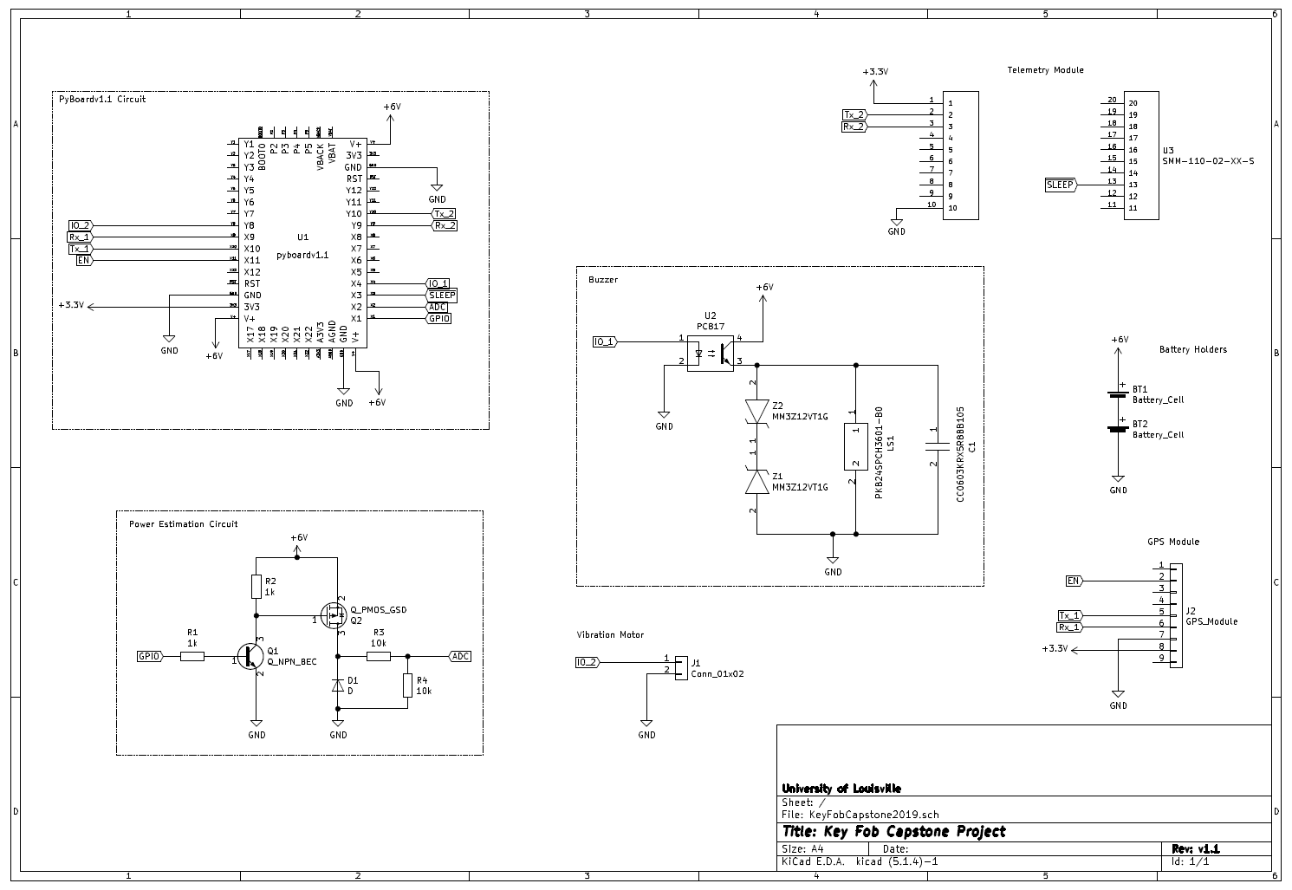

*Figure 8: Key Fob schematic with all major components.*

### Batteries

Two CR2450 coin cell batteries were selected to be used for the Key fob module. Each battery provides 3V and has a capacity of 620mAh. The two batteries were connected in series on the PCB to provide a supply voltage of 6V to power all the components of the system. These batteries failed because they have a discharge rate of only 200uA, less than the required draw from the key fob subsystem, this caused the batteries to drop in voltage from 6V to 2.5V within 5 seconds of powering the system. For the demonstration of the system and testing, a 9V battery was connected to the system. These CR2450 batteries insert into surface mounted coin battery holders on the PCB. The 9V was temporarily soldered in parallel to these battery holders and hangs loose on the system.

Four AA batteries were selected to power the car seat subsystem. Each battery supplies 1.5V and a capacity of 2500mAh. Put in series, there is once again a supply voltage of 6V, with a much higher capacity and discharge rate. The larger size of these batteries is also not a concern since they are used on the car seat module which does not have a critical a size constraint. The case that contains these batteries was glued to the bottom of the car seat case and the wires passed through aligned rectangular holes.

### XBee Telemetry Module

#### Connections

The application of the XBee Telemetry module for this system requires only four pins. Pin 1 supplies 3.3V and comes directly from the 3V3 output of the pyboard. Pin 2 and 3 are the transmit and receive pins, respectively. These pins are tied directly to a UART on the pyboard. This allows the pyboard on one subsystem to send data out on a UART through the XBee to the other subsystem via radio waves, and the pyboard on the other system will receive the data through the XBee also from UART. This is serial communication. Pin 10 ties the module to ground and pin 13 is the sleep pin. When this pin goes high, the telemetry module will enter low power mode to conserve power. This pin is tied directly to a GPIO on the pyboard. The typical transmit current draw of the XBee is 45mA and the typical receive draw is 50mA.

#### Configuration Settings

The XBee Telemetry Modules were configured using Digi’s free XCTU software. Both modules had their Firmware updated to the latest version of the Digi Xbee3 802.15.4 TH function set (2006). Only the settings that were changed from default will be discussed here. Configuration settings general to both the Key Fob Subsystem and Car Seat Subsystem are listed in **Table 1**. These settings are important to ensure the XBees can find each other. Tables of configuration settings specific to the Key Fob Subsystem and the Car Seat Subsystem can be found in **sections 3.1.1.1.1** and **3.1.1.1.2** respectively.

Table 1 : General Configuration Settings

|  |  |  |
| --- | --- | --- |
| Attribute ID | Attribute | Value |
| CH | Channel | 0x0C |
| ID | Network PAN ID | 0xCAFE |
| AP | API Enable | Transparent Mode [0] |
| D7 | DIO7/CTS Configuration | Disable [0] |
| PS | MicroPython Auto Start | Disable [0] |

##### **Key Fob Subsystem**

Table 2 : Key Fob Subsystem Specific Configuration Setting

|  |  |  |
| --- | --- | --- |
| Attribute ID | Attribute | Value |
| CE | Device Role | End-Point [0] |
| MY | 16-bit Source Address | 2 |
| DH | Destination Address High | 0 |
| DL | Destination Address Low | 1 |

##### **Car Seat Subsystem**

Table 3 : Car Seat Subsystem Specific Configuration Setting

|  |  |  |
| --- | --- | --- |
| Attribute ID | Attribute | Value |
| CE | Device Role | Coordinator [1] |
| MY | 16-bit Source Address | 1 |
| DH | Destination Address High | 0 |
| DL | Destination Address Low | 2 |

### GPS Breakout Board

The GPS breakout board ties into the subsystems with 5 pins. Pins 7 and 8 provide ground and 3.3V, respectively. Ground is common for every component, and the 3.3V supply voltage comes directly from the 3V3 line on the pyboard microcontroller. Pins 5 and 6 are the transmit and receive lines that are connected to a UART on the pyboard, allowing the pyboard to receive latitude and longitude information from the breakout board. Lastly, pin 2 is the enable pin, controlling when the GPS module receives data. The enable pin is important for power conservation because the operating current of this device, while tracking, is 25mA.

### Vibration Motor

The vibration motor operates as a standalone device in that all it requires to operate is an operating voltage of 2.7-3.3VDC. When this device receives this voltage, it is on. When it has no voltage supplied it is shut off. The state of this device is controlled through a GPIO pin on the pyboard. The motor was soldered then taped to the PCB, which allowed the subsystem to vibrate.

### Buzzer

The buzzer used is the PKB24SPCH3601-BO by piezo electric. The device came with a self-drive circuit making it a plug and play device, but for overcurrent protection, the recommended safety circuit was used. This circuit consists of two Zener Diodes that provide fly back protection and a capacitor is parallel to prevent over current. These circuit components can be seen more closely in **Figure 9**. Also present is an optocoupler relay which enables the system. The optocoupler is triggered by a GPIO pin on the pyboard to control when the buzzer should sound. The supply voltage for the buzzer, however, is not provided from the 3V3 regulated output like many of the other peripheral devices; it is supplied directly from the 6V system supply voltage. The reason that this is the case is because the supply voltage level is directly related to the sound pressure level (dB). While the buzzer is operable at 3VDC, it requires a higher voltage to meet the required dB level.

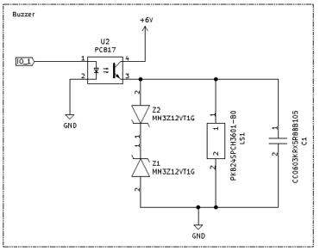

*Figure 9. Close up of the Buzzer Circuit.*

### Power Estimation Circuit

In order to measure the 6V input voltage of the power source a voltage divider was added. The voltage divided the 6V input down to 3V, which is a value the ADC of the pyboardv1.1 can read. The voltage divider circuit pulls a constant current of 300uA. To stop this the high-side driver was added to the circuit, seen in **Figure 10**. Using a GPIO pin on the pyboard the NPN BJT will pull the gate of the PMOS low allowing current to flow across the voltage divider. This reduces the passive current pull to 12.5nA, so only when the GPIO goes high will the current be 300uA. The simulation results for this circuit can be found in Appendix D. This circuit was solder on to the PCB. The components used surface mount packages. On the Key Fob subsystem this circuit is under the GPS module to save space.

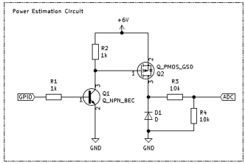

*Figure 10. Close up of the Power Estimation Circuit.*

### Pyboard

Seventeen pins are used on the pyboard to control every other major component in the subsystem. Three of these pins are supply voltage of 6V directly from the battery supply, and three of these are common ground connections. Also, in use are two UARTs, each with a receive and transmit pin. One of these UARTs connects to the telemetry module, and the other to the GPS breakout board. An analog to digital converter (ADC) connection is used to measure the output from the power estimation circuit. Five pins are used as a digital output, one to enable the GPS to collect data, one to enable sleep mode on the telemetry module, one provides power to the vibration motor, one activates the buzzer, and the last allows the ADC to read the present supply voltage level. Each of these peripheral devices is connected to the pyboard because the pyboard houses a STM32F405 microcontroller. This microcontroller allows the system to enable peripherals during the correct state based upon information received by the GPS and sent by the telemetry modules. The final pin that is used provides the 3.3V rail to power both the GPS breakout and the telemetry module. This regulated output has a maximum draw of 250mA.

### Printed Circuit Board

The printed circuit boards were designed using KiCAD and ordered from PCBWay. **Figures 8, 11, and 12** were all designed using KiCAD. Most of the parts used were standard library parts but the schematic symbol and footprint had to be created for the GPS module and the pyboard v1.1. The board is two layers and each layer contains a ground plane. The board project was converted into a Gerber file which contains all the data required for a company such as PCBWay to manufacture the board. Every part apart from the telemetry module on the car seat subsystem was soldered directly to the PCB with male to male headers, surface mount, or through-hole connections. The green and red traces seen in **Figures 11 and 12** show the connections between pins and devices on opposite sides of the board. Also the ground planes are not shown.

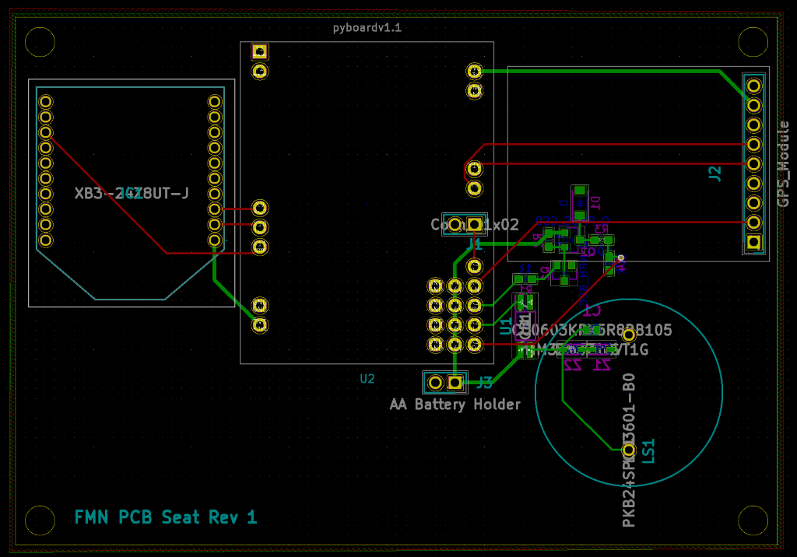

Figure 11: Car Seat subsystem PCB Layout.

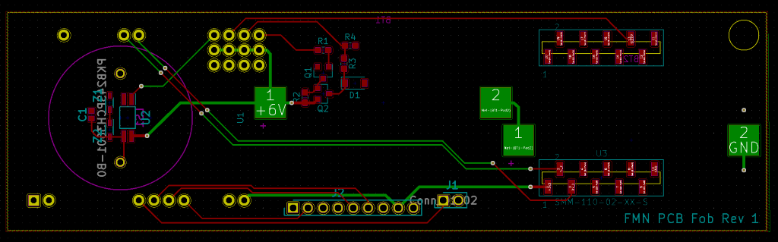

Figure 12: Key Fob subsystem PCB layout.

### 3D Case Design

Each case was designed to house the PCB and components for the related subsystem. These parts determined the outside dimensions of the 3D design. As a standard, all walls were created to be 3 mm thick minimum for stability. Each case top also features a cutout window to place the diffuser lens in. A LED display lens was bought and cut to fit the windows. The dimensions this lens was cut are 6 mm by 22 mm. The display lens bought already has a width of 22 mm so only one cut was necessary for it to fit the case. Each pair of case halves also have a lip of width 1.5 mm to help the system snap together. This lip runs along the external wall of the case, extruding outward on the top and cut inward on the bottom. Both subsystems have an audible alarm and therefore both required a hole for the sound of the buzzer to not be muted. This was accomplished with a flower shaped pattern. Both systems make use of #6-32 screws to hold the two halves together. These screws thread into the plastic holes that have a smaller diameter than the screws. The keyfob case is held together by a 1” screw and the car seat case by ¾” screws. Lastly, both cases feature a cut out and hole for the pushbuttons to mount into. The drawing files for pushbuttons and pushbutton shafts can be found in Appendix I. The shafts slide easily halfway through the holes and then are super glued to the pushbutton tops to create a simple solution which will allow the user to interface the external buttons while operating the pushbuttons present on the pyboard.

#### Keyfob Case Exclusive Features

Some features exclusive to the keyfob case include a battery cover and housing for a square nut, a extrusion to help align the pushbutton shafts, and a housing for the vibration motor. The batteries on this subsystem were originally mounted directly onto the PCB so an access point had to be created to allow the end user to change the batteries without taking apart the entire system. The solution to this problem was to create a battery cover which slides and screw into place. **Figure 13** shows a cutout in the bottom of the case and a rectangular housing for a square nut that the screw will be held by. An M3 machine screw and square nut were used for this solution to reduce the likelihood of the stripping plastic due to removing and attaching the battery cover multiple times. Once printed, it was discovered that the battery cover was secured from falling off but could be pushed up into the system. The fix for this problem was to super glue a piece from the excess diffuser lens to create a lip that prevents the cover from being pushed up. This is a work-around fix and should be addressed in any future iterations of the project.

The right image of **Figure 13** shows an extrusion with two holes cut into it. The top case for the keyfob is very tall to accommodate the thickness of the GPS antenna. This excess height had the potential to allow the pushbuttons to be pressed in a way that would cause them to miss the button on the pyboard. Therefore, the extrusion shown is to help the pushbutton shafts remain straight when being operated. There was another extrusion created to house the vibration motor to ensure that while vibrating, the entire case would as well. Unfortunately, this feature didn’t print correctly, and the motor was just stuck to the case using the adhesive it was shipped with. This is another feature that must be addressed in any future development of the system. The GPS antenna also was too thick and was stuck to the top of the case with the adhesive it was shipped with. The RF antenna was stuck to the inside top of the case using the adhesive it was shipped with.

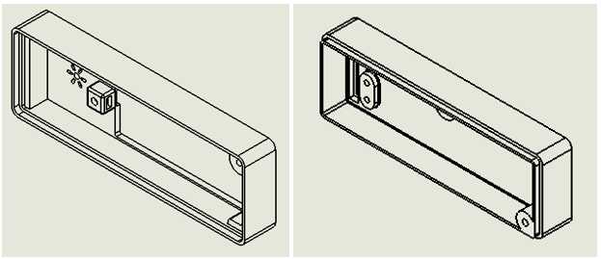

*Figure 13: The two halves of the keyfob case.*

#### Carseat Case Exclusive Features

Some features exclusive to the carseat case include an external hole for the battery wires, screw holes specifically to hold the PCB into place, and a groove for the GPS antenna wire to fit through. Due to the less critical size constraint of the carseat system, rather than mount batteries onto the PCB, a battery holder with lead wires was bought. A link to this holder can be found in Appendix B. This holder has a rectangular hole in it that was matched on the carseat case to allow the lead wires to pass into the case and solder onto the PCB without being exposed to the user. The battery holder case comes with a sliding cover for easy battery replacement and was glued into the bottom of the carseat case. A difference between **Figure 13** and **Figure 14** is the number of screw holes used to hold the halves together. In the right image of **Figure 14**, two screws holes can be seen for screws that go through the entire system compared to the one in **Figure 13**. However, comparing the right and left images in **Figure 14** shows that the bottom half of the case has four such holes for mounting screws. Two of these holes are for #6-32 x ¼” screws to hold the PCB in place even when the top half of the case is disconnected.

The last exclusive feature is a groove not pictured in **Figure 14** which allows the GPS antenna to rest underneath the PCB while being connected to the breakout board on the top. The thickness of the wire originally prevented the antenna from accessing the bottom of the board. This groove was misplaced and instead, a larger rectangular groove was cut out using a Dremel tool to allow the same placement of the antenna. This antenna was stuck underneath the PCB with the antenna facing upwards.

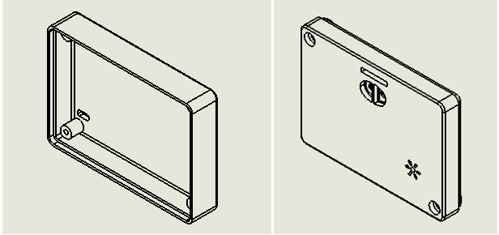

*Figure 14: The two halves of the car seat case.*

## Software Detailed Design

The software was designed to be object oriented with parallel processes running for communication. It was written in MicroPython, a lite version of python 3.5 with curtailed modules for embedded programming. To enable threading capability, the firmware on the pyboards had to be updated to version 1.11. An SSH terminal program, PuTTY, was used to monitor and debug the subsystems during runtime.

The Car Seat Subsystem and the Key Fob Subsystem both have a GPS module update thread to update its position as well as their own unique man threads. The Car Seat Subsystem uses a Telemetry Module Broadcast Position Thread to report its position over radio frequency. The Key Fob Subsystem uses a Telemetry Module Listen Thread to listen for broadcasts from nearby Car Seat Subsystems. It is important to note that the python enumeration class is not available in MicroPython. Strings were used in place of enumerations.

### Class Objects

The software is designed around one class object Subsystem that has three additional attributes that are classes as well: telemetry module, GPS module, and power estimator. Below are descriptions of each class object, a table of their attributes, and a list of associated class methods with heir descriptions.

#### Subsystem

The subsystem class object encapsulates all functional classes. It has an attribute for each functional class as well as attributes for peripheral hardware locations. This allows for easy configuration between the two subsystems depending on the attribute subsystem_type. Subsystems with the ‘car_seat’ subsystem type work as a Car Seat Subsystem. Subsystems with the ‘key_fob’ subsystem type work as a Key Fob Subsystem. It has additional variable attributes to keep track of the alarm’s state, thread functionality state, and the time since its disarmed button was pressed. Both subsystems have a pyb.Switch class object that is initialized with the Subsystem.disarm function as its callback function. The reset button on the pyboard will restart the program as if the system was just powered up.

Table 4: Subsystem Attributes

|  |  |
| --- | --- |
| Attribute | Description |
| subsystem_type | This attribute is assigned at initialization. It is of type string and can be either ‘key_fob’ or ‘car_seat’. |
| power_estimator | This attribute represents a class object that is built from variables passed during initialization. It uses variables power_estimator_adc_pin_name and power_estimator_adc_gpio_pin_name. |
| telemetry_module | This attribute represents a class object that is built from variables passed during initialization. It uses variable telemetry_module_uart_pin_number. |
| gps_module | This attribute represents a class object that is built from variables passed during initialization. It uses variable gps_module_uart_number. |
| buzzer_pin | The buzzer_pin is a pyb.Pin class object representing an out GPIO pin. It uses variable buzzer_pin_name. |
| vibration_motor_pin | The vibration_motor_pin is a pyb.Pin class object representing an out GPIO pin. It uses variable vibration_motor_pin_name. It is initialized to False. |
| alarm_ringing | A Boolean denoting whether or not the alarm is currently sounding. |
| stop_flag | A Boolean denoting whether or not the threads have been signaled to stop communicating with the hardware. This is used for low power mode. It is initialized to False. |
| time_since_disarm | A floating point denoting the amount of time in seconds since the disarm or snooze button was last pressed on this subsystem. It is initialized to the maximum amount of snooze for the system. In the case of the key_fob system this value is initialized to 120. |
| armed | A Boolean denoting whether or not the subsystem is currently armed. It is initialized to True for subsystem type ‘car_seat’ and False for subsystem type ‘key_fob’. |

##### **init(subsystem_type, power_estimator_adc_pin_name, power_estimator_adc_gpio_pin_name, telemetry_module_uart_pin_number, gps_module_uart_number, vibration_motor_pin_name, buzzer_pin_name)**

This method initializes the class object. It takes the attributes described in **Table 4** above. It returns a class object of type Subsystem with access to the methods described in **sections 3.2.1.1.2-3.2.1.1.6** of this document.

##### **run()**

This starts all threads for the subsystem including the main thread. As previously mentioned, if the subsystem is of type ‘car_seat’ it starts a GPS Module Update Thread, a Telemetry Module Broadcast Position Thread, and the main thread described in **section 2.4.4** of this document. On the other hand, if the subsystem is of type ‘key_fob’ this method starts a GPS Module Update Thread, a Telemetry Module Listen Thread, and the main thread described in **section 2.4.5** of this document.

##### **sound_alarm()**

This method acts as a switch. If the alarm_ringing attribute is set to True, it sets the buzzer and vibration motor pins to high and sets the alarm_ringing attribute to False. On the other hand, if the alarm_ringing attribute is set to False, it sets the buzzer and vibration motor pins to low and sets the alarm_ringing attribute to True.

##### **quiet_alarm()**

This method simply sets the buzzer and vibration motor pins to low.

##### **disarm_alarm()**

This method sets the armed the armed attribute to False and sets the time_since_disarm attribute to. Furthermore, it calls the quiet_alarm method described above.

##### **calculate_distance_between_subsystems()**

This method calculates the distance between the subsystems in meters and the last subsystem it communicated with. It gets its location by calling the get_location method on its Subsystem.GPS_Module class object (see **section 3.2.1.3.2**). The location to subsystem it last communicated with is gathered from the last_latitude and last_longitude attributes of its Subsystem.TelemetryModule class object. If any of the latitude or longitude values are 0, the subsystem assumes one of the GPS is not working and returns 0. If all latitude and longitude values are valid, the method uses the haversine formula described in **section 3.2.2**.

#### Subsystem.TelemetryModule

The Telemetry Module class object is used to encapsulate all communication with the telemetry module hardware. The class object has one class object attribute uart it uses to send and receive communication with the telemetry module hardware. It also has additional variable attributes used to keep information regarding its recent messages received. It is important to note the Car Seat subsystem never accesses any of the variable attributes described below; only the Key Fob Subsystem utilizes these.

Table 5 : Telemetry Module Attributes

|  |  |
| --- | --- |
| Attribute | Description |
| uart | A pyb.UART class object. It uses the variable uart_number and initializes with a baud rate of 9600 Hz. |
| last_longitude | This is a floating-point value denoting the last longitude value sent to the telemetry module from another subsystem. The value is initialized to 0. |
| last_latitude | This is a floating-point value denoting the last latitude value sent to the telemetry module from another subsystem. The value is initialized to 0. |
| time_since_disarm | This is a floating-point value denoting the amount of time in seconds since a disarm Boolean was received from the telemetry module of another subsystem. The value is initialized to the max time since disarm, 300s or 5 minutes. |
| time_since_last_message | This is a floating-point value denoting the amount of time in seconds since a valid message has been received from the telemetry module of another subsystem. The value is initialized to the max amount of wait time since last message, 15 seconds. |
| last_armed | This is a Boolean value denoting the last armed state sent to the telemetry module from another subsystem. It is initialized to a Boolean value of False. |

##### **init(uart_number)**

This method initializes the class object. It takes the attributes described in **Table 5** above. It returns a class object of type Subsystem with access to the methods described in **sections 3.2.1.2.2-3.2.1.2.3** of this document.

##### **send_message(message)**

This method takes a variable of type string message and writes it to its uart attribute.

##### **decode_message(message)**

This method is a static method, not a class method but deserves explanation. It takes an argument message which it assumes has been checked for validity. It returns a Boolean armed variable, and two floats latitude and longitude retrieved from the string using python parsing techniques.

#### Subsystem.GPS_Module

The GPS Module class object is used to encapsulate all communication with the GPS module hardware. The class object has one class object attribute uart it uses to send and receive communication with the GPS module hardware. It also has a MicroGPS class object it uses to parse and validate the strings received across UART.

Table 6 : GPS Module Attributes

|  |  |
| --- | --- |
| Attribute | Description |
| uart | A pyb.UART class object. It uses the variable uart_number and initializes with a baud rate of 9600 Hz. |
| gps | A MicroGPS class object. This is an open source parser found on GitHub. There is a link to repository in the references section of this document. It is used to decode strings received from the GPS hardware module. |

##### **init(uart_number)**

This method initializes the class object. It takes the attributes described in **Table 6** above. It returns a class object of type Subsystem.GPS_Module with access to the get_location method.

##### **get_location()**

This method returns the latitude and longitude attributes retrieved from the MicroGPS class object. These attributes represent the last valid update the GPS module received. It is important to note, that if not valid update has been received by the GPS module, these attributes will return 0.

#### Subsystem.PowerEstimator

The PowerEstimator class object is used to encapsulate all communication with the power estimation circuit. It has access to one method which it uses to update its attributes as well as return a recent power estimation.

Table 7 : Power Estimator Attributes

|  |  |
| --- | --- |
| Attribute | Description |
| adc_pin | A pyb.ADC class object that takes a pyb.Pin class object as an argument. The pyb.Pin class object uses the variable adc_pin_name. |
| gpio_pin | A pyb.Pin class object that uses the variable gpio_pin_name. |
| starting_counts | A type Int attribute with range 0-4096. Denotes the initial counts read from the ADC when the subsystem is first powered. It is initialized to a null value. |
| percent_power_remaining | A floating-point attribute denoting an estimate of the percentage of power remaining by taking the most recent adc reading and dividing it by the starting_counts attribute. |

##### **init(adc_pin_name, gpio_pin_name)**

This method initializes the class object. It takes the attributes described in **Table 7** above. It returns a class object of type Subsystem.PowerEstimator with access to the get_power_estimate() method.

##### **get_power_estimate()**

This method starts by setting its gpio pin to high, reading the number of counts from the adc pin, and then setting the gpio pin back to low. If the starting_count attribute is still a null value, it sets the attribute to be equal to the number of counts recently read and sets the percent_power_remaining attribute to 100.0. If the starting counts is not a null value, it sets the percent_power_remaining attribute to the number of counts recently read divided by the starting_counts attribute times 100. It then returns the updated percent_power_remaining attribute.

### Distance Calculation

The Haversine equation was used for calculating the distance between two GPS coordinates. Each GPS coordinate is represented as a pair of latitude and longitude floating point values. The distance between these two coordinates is then calculated using the Haversine Formula described in **Equation 1** below where $ϕ$ represents the latitude of a coordinate and λ represents the longitude.

Equation 1 : Haversine Formula



# Test Procedures and Results

## Test Procedures

### Temperature Test

The Temperature Test requires the system's communication to be tested while one of the subsystems is held in an environment with a temperature of 175 degrees **Fahrenheit**. This can be done using a standard oven by first preheating it to 175 degrees and double checking the internal temperature of the oven using a thermometer. The system must be able to create an alarm event under these circumstances and successfully rearm itself after the user re-enters the perimeter.

#### Requirements Traceability

* 2.2.1 - The system must be able to survive heat of 175 degrees Fahrenheit.

### Longevity Test

The Longevity Test requires the system to operate properly for 8 ± 1 days with at least 2 alarm and rearm events occurring each day of operation. This ensures long duration working operation of the system.

#### Requirements Traceability

* 2.2.1 – The system must retain working power for 8 ± 1 days on a single full charge.

### Sizing Test

The Sizing Test requires the system to be measured to assure each subsystem is within its dimensional requirements. The Key Fob Subsystem must measure to have a width less than 5.5”, a height of less than 3”, and a thickness of less than 1.5”. The Car Seat Subsystem must measure to have a width less than 5”, a height of less than 5”, and a thickness of less than 2.5”.

#### Requirements Traceability

* 2.2.3 - Key Fob Subsystem shall be no larger than 5.5”x3”x2.5”.
* 2.2.4 - Car Seat Subsystem shall be no larger than 5”x5”x2.5”.

### Alarm Disarm Test

The Alarm Disarm Test validates the alarm is shut off when the disarm button is pressed. The operator must create a circumstance where an alarm event occurs by walking outside of a perimeter for 30 meters ± 10 meters from the car seat subsystem with the key fob subsystem while the alarm is armed.

#### Requirements Traceability

* 2.2.6 - The system shall be disarmed by pressing the disarm button on the Car Seat Subsystem.
* 2.2.7 - Key Fob Subsystem shall make audible sound and vibrations once the fob exits a 30m ± 10m perimeter around the car module before the alarm is disarmed.

### Sound Test

The Sound Test ensures the alarm reaches an intensity level of 80dB ± 5dB. The intensity level must be measured from a distance of 1 meter from the system to account for the distance between the operator’s pocket and their ear. The intensity level will be checked using a smartphone decibel meter app.

#### Requirements Traceability

* 2.2.8 - The system’s alarm sound should reach 80dB ± 5dB.

### Rearm Test

The Rearm Test requires the operator to disarm an armed alarm while in the perimeter, walk outside of the perimeter of 30m ± 10m without an alarm event occurring, re-enter the perimeter, and then leave the perimeter with an alarm event occurring. This ensure that the subsystem properly rearmed itself after reentering the perimeter area.

#### Requirements Traceability

* 2.2.9 - Alarm shall rearm automatically when user re-enters the perimeter of 30m ± 10m from the Car Seat Subsystem.

### Low Power Test

The Low Power Test requires the user to use a direct current power supply to lower the input voltage from 6 volts to below 3.3 volts. Once at low power the subsystem must begin blinking its low power LED to warn the user. Additionally, the subsystem must stop utilizing its telemetry and GPS modules to ensure the warning LED stays on as long as possible. This can be tested by ensuring the broadcast from the subsystem stops once the LED begins to blink.

#### Requirements Traceability

* 2.2.10 - The system shall alert the operator via low power LED.
* 2.2.11 - The Key Fob Subsystem must operate with reduced functionality at low power.

## Test Results

Attached in the appendix is the spreadsheet on which the data was collected.

### Temperature Test

This test was not completed. The team did not have time or a way to test the system at temperatures of 175 degrees Fahrenheit. Some parts are rated to work at these temperatures and others are not. This test will have to be completed later.

### Longevity Test

This test was not completed. There was not time to test the longevity of the batteries. The complication with the battery choice for the Key Fob also did not allow for this test to be completed. Note that from calculations done before and current battery selection if this test was completed the system would most likely fail in the first day.

### Sizing Test

The system passed this test. The Key Fob subsystem had a final dimension of 5.375”x 1.75”x1.5”. The Car Seat subsystem had a final dimension of 4.25”x3”x2.0625”.

### Alarm Disarm Test

This test was completed a total of five times. Four of the tests were completed by pressing the disarm button then forcing the Key Fob to use connection to the Car Seat subsystem. All the tests displayed that the Key Fob was disarmed because signals could be viewed using a PuTTY. The last test was completed by walking out of RF range after the disarm button was pressed. All five of the tested passed as noted in **Table 8**.

Table 8 : Alarm Disarm Test Results

|  |  |  |  |
| --- | --- | --- | --- |
| Run | Pass | Fail | Notes |
| 1 | X |  | Powered supplied by computer, data viewed in a PuTTY |
| 2 | X |  | Powered supplied by computer, data viewed in a PuTTY |
| 3 | X |  | Powered supplied by computer, data viewed in a PuTTY |
| 4 | X |  | Powered supplied by batteries |
| 5 | X |  | Powered supplied by computer, data viewed in a PuTTY |

### Sound Test

This test has not been completed. The test will have to be completed later.

### Rearm Test

This test was completed a total of five times. Two tests were completed on the computer so the data could be view using a PuTTY terminal. A test was completed using only RF and both units powered by their batteries. The Key Fob was taken out of range and rearmed when walked back into range. The last two tests where completed with GPS. As the Key Fob subsystem was taken 30m ± 10m meters away, the alarm would sound and if brought back into range the alarm would disable. All five tests passed as noted in **Table 9**.

Table 9 : Rearm Test Results

|  |  |  |  |
| --- | --- | --- | --- |
| Run | Pass | Fail | Notes |
| 1 | X |  | Powered supplied by computer, data viewed in a PuTTY |
| 2 | X |  | Powered supplied by computer, data viewed in a PuTTY |
| 3 | X |  | Powered supplied by batteries |
| 4 | X |  | Powered supplied by batteries, GPS enable, tested in car |
| 5 | X |  | Powered supplied by batteries, GPS enable, tested in car |

### Low Power Test

This test was completed using a DC power supply. The power supply was set to 6 volts then to simulate power decay the power supply was lowered to below 3.3V. At this point the low power system activated causing the LEDs and buzzer to activate. This can be seen in a video in the attached documentation.

## Requirements Traceability

Table : Requirements Traceability Matrix

|  |  |  |  |
| --- | --- | --- | --- |
| **Requirement** | **Requirement Description** | **Test** | **Pass/Fail** |
| 2.2.1 | The system must be able to survive heat of 175 degrees. | 4.1 | TBD |
| 2.2.2 | The system must retain working power for 8 ± 1 days on a single full charge. | 4.2 | TBD |
| 2.2.3 | Key Fob Subsystem shall be no larger than 5.5”x3”x1.5”. | 4.3 | Pass |
| 2.2.4 | Car Seat Subsystem shall be no larger than 5”x5”x2.5”. | 4.3 | Pass |
| 2.2.5 | The system shall be disarmed by pressing the disarm button on the Car Seat Subsystem. | 4.4 | Pass |
| 2.2.6 | Key Fob Subsystem shall make audible sound and vibrations once the fob exits a 30m ± 10m perimeter around the car module before the alarm is disarmed. | 4.4 | Pass |
| 2.2.7 | The system’s alarm sound should reach 80dB ± 5dB. | 4.5 | TBD |
| 2.2.8 | Alarm shall rearm automatically when user re-enters the perimeter of 30m ± 10m from the Car Seat Subsystem. | 4.6 | Pass |
| 2.2.9 | The system shall alert the operator via low power LED. | 4.7 | Pass |
| 2.2.10 | The Key Fob Subsystem must operate with reduced functionality at low power. | 4.7 | Pass |

# Conclusions

As described throughout this document, we had several goals at the outset of this project. We wanted to reduce the size of the previously designed system to the point it could be sold as a ‘key fob’ sized system. We wanted to add a GPS to the list of hardware modules to approximate the distance between the two subsystems. And lastly, we wanted to add power estimation functionality as well as implement a baseline low power state to reduce power use.

During our post analysis of the subsystems, we determined there was an ~80% size reduction of Car Seat Subsystem and a ~70% size reduction of the Key Fob Subsystem. The Key Fob Subsystem is slightly larger than what might be commonly regarded as ‘key fob’ size; although, it would fit in many purses given its current design. Further ideas for reducing size are discussed in **section 6.2** of this document.

Two GPS Modules were successfully integrated into the system. There is important information on improvements that can be made to the GPS Module’s hardware design. The Haversine equation was shown to very accurately calculate the distance between two sets of GPS coordinates. When both subsystems were about a foot apart, they would report a distance difference of 0.4-0.6 meters. Furthermore, when the GPS modules were stationary, the error between the calculated distance and the actual distance was reduced over time.

Lastly, we were successful in our implementation of a power estimation circuit. The circuit gives an unsigned integer of counts from 0-4096 giving the amount of power remaining from the system. The circuit can only provide a maximum estimate of 3.3V. Since the subsystems are given an initial voltage of 6V, the power estimation circuit can only estimate values below 3.3V. Furthermore, it is important to note power estimation using ADC registers are notoriously inaccurate at low voltages.

# Recommendations for Future Work

## Software Future Recommendations

There are several improvements that can be made to the software to make the system more robust, reduce power consumption, and add additional functionality.

There are many edge cases that are not accounted for in the current implementation. During testing, we saw situations where one subsystem would get an update from a GPS satellite out of sync with the other subsystem. This can artificially cause them to be further or closer apart than the subsystems will calculate in this circumstance. Checks could be added to the velocities of each subsystem to mitigate the false positives this could cause when the user is moving at high speeds such as when driving. Furthermore, if the current software implementation is to be used further, it is suggested that an exhaustive set of tests should be done first to ensure full functionality as we only had a day to test and did not have time to track all edge cases.

Several of the components have additional functionality to reduce power that could be tapped into. The telemetry modules have a sleep mode that is currently forced to always be off. Additional logic could be implemented to utilize this sleep mode as much as possible; especially when the subsystem is put into low power mode. Additional improvements may be possible in the structuring of the threading. Several threads are scheduled at a high frequency when in low power mode that have low functionality. A rethinking of the scheduling at low power could be a real improvement to device lifetime.

Additional functionality has been discussed between the team since deriving our initial requirements. These include adding the possibility of having multiple key fob subsystems that could be connected to multiple car seat subsystems. This is important as families often have more than one kid with more than one caretaker. The telemetry modules will need to have their MY, DH, and DL attributes edited to accommodate this on top of software additions. Furthermore, two-way communication could be helpful to add additional redundancy before an alarm event although the system has not shown any cases of false positive alarm states.

## Hardware Future Recommendations

The most important future recommendation for hardware is to ensure the GPS module has a constant power source or find a GPS module that does not require a long start up period to download the almanac. We found the GPS modules would struggle to download this almanac ever when inside or with poor reception but would retain connection to satellites with good reliability as long as the GPS hadn’t lost power since its first connection to a GPS satellite. In our initial research, this additional power source was thought to be optional but is required for a robust working system with these requirements.

Future iterations of hardware design on the Forget Me Not Child Safety System should once again focus on reducing size. There are two separate capstone projects that are recommended to happen independently. The first is to reduce the size of the system by incorporating the circuits for all the different functions together onto a single board. This could be done by buying the required ICs and related circuit elements used on the pyboard, GPS breakout, and telemetry modules independently of the breakout boards and creating a PCB for those components. This would greatly reduce the required footprint of these components. In this project, it is also recommended that an alternative to the current GPS antenna is found.

The second recommended hardware project that could stem from the product developed this semester would tackle the power issues. New power sources should be explored, and a new battery option selected that can meet the footprint and power constraints. Also included in this project would be incorporating the low power mode software features available on the COTS breakout boards that were selected.

In either of these future projects, functionality for connecting multiple keyfob modules to multiple carseat modules could be incorporated as well as a syncing function, a previously expressed desire for the product. Redesigning the footprint would also require changes to be made to the 3D case, to create a smaller system.

# References

[*microGPS*](https://github.com/inmcm/micropyGPS) *- A Full Featured GPS NMEA-0183 sentence parser for use with Micropython and the PyBoard embedded platform*

[*Haversine Formula Wikipedia*](https://en.wikipedia.org/wiki/Haversine_formula)

*Hot Car Deaths: Scientists Detail Why Parents Forget Their Children. NBC News. June 27, 2017.* <https://www.nbcnews.com/storyline/hot-cars-and-kids/hot-car-deaths-scientists-detail-why-parents-forget-their-children-n777076>

# Appendices

## APPENDIX A:Sponsor/Team Contact Information

Sponsor Contact Information:

Laura Ochsner

[lauraochsner@hotmail.com](mailto:lauraochsner@hotmail.com)

(502)387-8887

Team members can be contacted at:

Raley Suter

[raley.suter@louisville.edu](mailto:raley.suter@louisville.edu)

Jacob Cassady

[jacob.cassady@louisville.edu](mailto:jacob.cassady@louisville.edu)

Mason Gardone

mason.gardone@louisville.edu

## APPENDIX B: Data Sheet Links

### Telemetry Module

XBee/XBee-PRO S1 802.15.4 Datasheet - <https://www.digi.com/resources/documentation/digidocs/pdfs/90000982.pdf>

### GPS Module

FGPMMOPA6H GPS Standalone Module Datasheet - <https://cdn-shop.adafruit.com/datasheets/GlobalTop-FGPMMOPA6H-Datasheet-V0A.pdf>

PMTK Command Set Sheet - <https://cdn-shop.adafruit.com/datasheets/PMTK_A11.pdf>

LOCUS (built-in-data logging system) user guide - <https://cdn-shop.adafruit.com/datasheets/GTop+LOCUS+Library+User+Manual-v13.pdf>

### PyBoardv1.1

Microcontroller (STM32F405RG) Datasheet - <https://www.st.com/en/microcontrollers-microprocessors/stm32f405rg.html>

Micropython Programmers Manual - <http://docs.micropython.org/en/v1.9/pyboard/index.html>

Pyboard Quick Reference - <http://docs.micropython.org/en/latest/pyboard/quickref.html>

### Power Source

#### CR2450

<https://b2b-api.panasonic.eu/file_stream/pids/fileversion/3648>

#### CR2450 Holder

<http://www.memoryprotectiondevices.com/datasheets/BU2450SM-JJ-GTR-datasheet.pdf>

#### LR6XWA/B

<https://b2b-api.panasonic.eu/file_stream/pids/fileversion/3678>

#### LR6XWA/B Holder

<https://www.digikey.com/product-detail/en/mpd-memory-protection-devices/SBH341A/SBH341A-ND/2439569>

### Power Estimation Circuit

#### BSR17A

<https://www.onsemi.com/pub/Collateral/BSR17A-D.pdf>

#### BSH202,215

<https://assets.nexperia.com/documents/data-sheet/BSH202.pdf>

#### BAV19W-E3-08

<http://www.vishay.com/docs/85725/bav19w.pdf>

#### MCT06030C1002FP500

<http://www.vishay.com/docs/28705/mcx0x0xpro.pdf>

#### MCT06030C1001FP500

<http://www.vishay.com/docs/28705/mcx0x0xpro.pdf>

### Sixfab Internal Active GPS Patch Antenna

<https://sixfab.com/product/internal-active-gps-antenna-15db-25mm-x-25mm-u-fl-plug/?utm_medium=ppc&utm_campaign=US+Smart+Shopping&utm_term=&utm_source=adwords&hsa_src=u&hsa_net=adwords&hsa_kw=&hsa_tgt=pla-293946777986&hsa_ad=355845382964&hsa_grp=78850140224&hsa_mt=&hsa_acc=6308888758&hsa_ver=3&hsa_cam=2037647658&gclid=Cj0KCQjw3JXtBRC8ARIsAEBHg4mSzIN8WAyl86ccdp28ZW-_khK69C30LfbSgaW_Ql739PRHlUxMxKoaArKoEALw_wcB>

### W24P-U OEM Wi-Fi Antenna

<https://www.inventeksys.com/wp-content/uploads/W24P-U_2.4Ghz_-Antenna_Specification.pdf>

### Coin Vibration Motor

<http://www.vibration-motor.com/wp-content/themes/vibration-motors/dk-pdf/products/download/C1020B111F.pdf>

### Piezoelectric Buzzer PKB24SPCH3601-B0

<https://www.murata.com/~/media/webrenewal/support/library/catalog/products/sound/p37e.ashx?la=en-us>

## APPENDIX C: Diagrams and Pictures

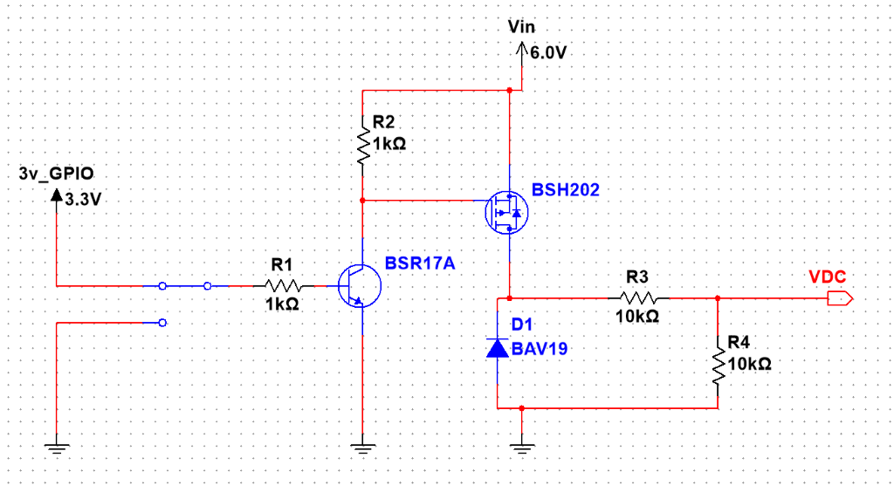

Figure 15: Power Estimation Circuit Diagram.

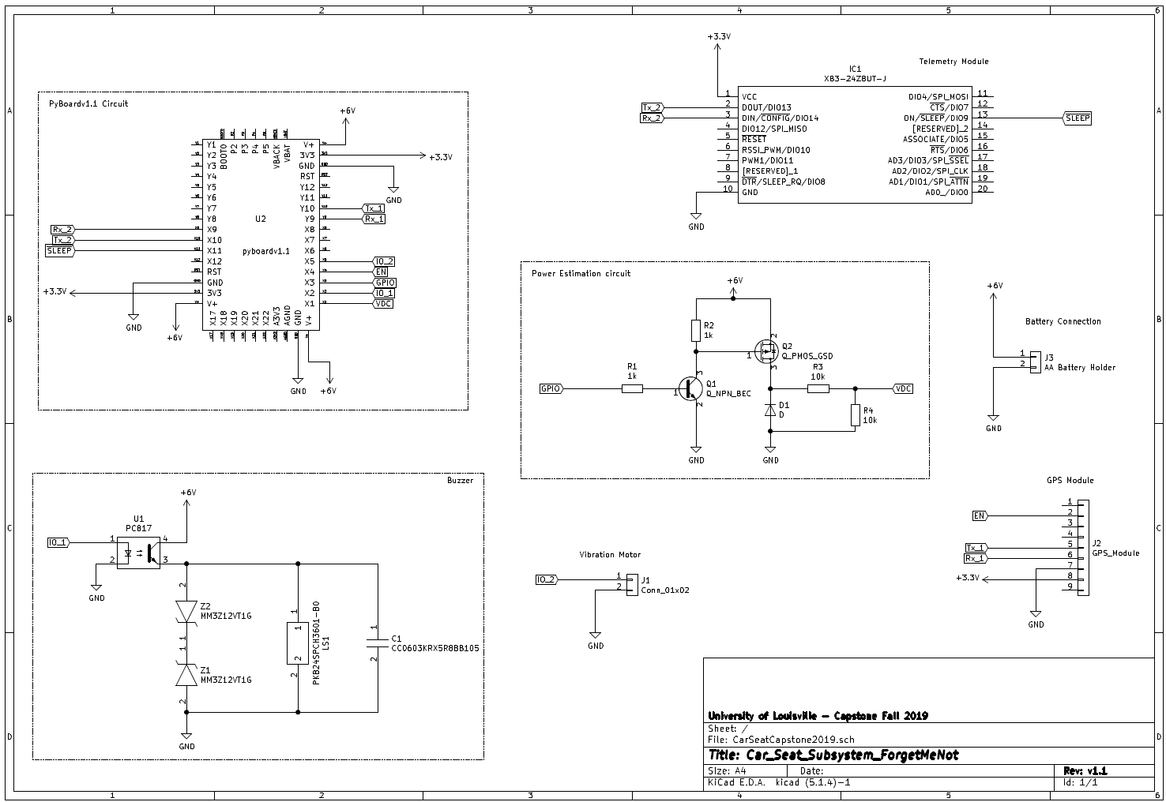

*Figure 16: Carseat Subsystem Schematic.*

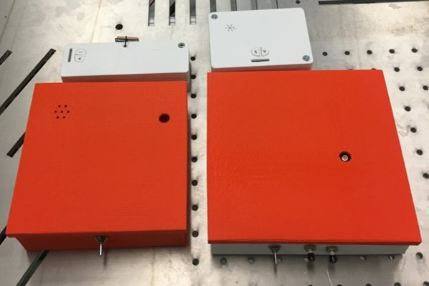

*Figure 17: Size comparison between Iteration 1 and 2 of the product.*

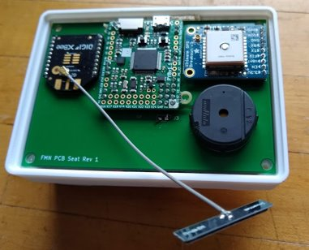

*Figure 18: Populated PCB of the Carseat Module.*

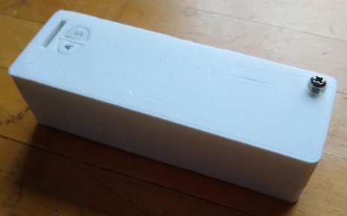

*Figure 19: Keyfob Subsystem.*

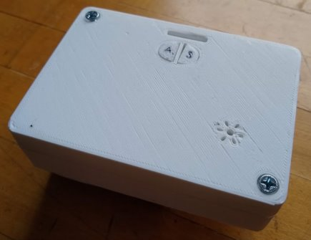

*Figure 20: Carseat Module.*

## APPENDIX D: Simulation Results

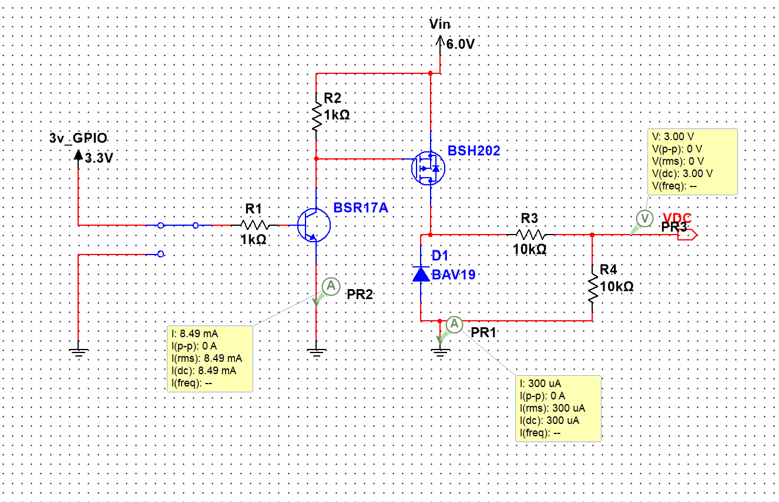

Figure 89: Power Estimation Circuit Simulation results with GPIO high.

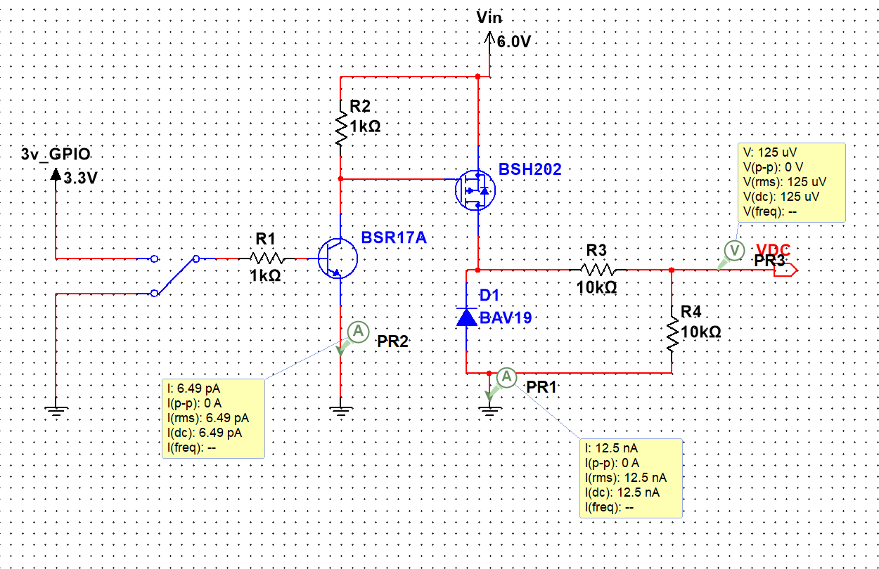

Figure 20: Power Estimation Circuit simulation results with GPIO low.

## APPENDIX E: Software installation instructions

### Solidworks

SolidWorks is the software used to create the 3D case designs and can be downloaded and installed from their website. <https://www.solidworks.com/sw/support/downloads.htm>

In order to use this software, it must be purchased. However, UofL speed school provides student access which can be downloaded from the Speed Bundle website.

<https://engrapps.spd.louisville.edu/SpeedBundle/Account/Login?ReturnUrl=%2fSpeedBundle%2f>

Login using Ulink student ID and click on the Software tab at the top center. Expand the Solidworks folder and pay special attention to the SEK-ID and serial number when following the download link.

### Cura

Cura is the software used to convert SolidWorks 3D part files into a format that the 3D printer can print, namely, .gcode files. The latest version of the Cura software can be downloaded for free from the following link. (As of 12/19) <https://ultimaker.com/software/ultimaker-cura>

There are many settings that can be configured to modify the quality and speed of the print. The default settings were used for the prints in this project. Once Cura is installed, if operating on a Windows 10 machine, there is a known issue that may prevent the program from opening. The first work around to try if this happens is to right click on Cura.exe and select troubleshoot compatibility. This should give you the option to run the program using a Windows 8 configuration. If this doesn’t work, there are forums that may provide further work arounds.

Once installed and opened, click on the Marketplace tab in the top right corner and install the SolidWorks plugin. This will allow you to import .SLDPRT files directly into the program. To convert to a .gcode file, simply click Slice when a part is in the printing field.

### XCTU

XCTU is free configuration software by Digi for updating configuration registers on XBee telemetry modules. Installation instructions for the XCTU software can be found on Digi’s website [here](https://www.digi.com/resources/documentation/digidocs/90001526/tasks/t_download_and_install_xctu.htm?tocpath=Set%20up%20%20your%20XBee%20devices%7CDownload%20and%20install%20XCTU%7C_____0).

### KiCAD

KiCAD is a cross platform and open source electronics design automation suite useful for creating and simulating schematics as well as creating and routing PCBs. This software can be downloaded at the following URL. Libraries can also be downloaded from the same site, prepopulating the software with the footprints and characteristics of many common components used in circuit design. <https://kicad-pcb.org/>

### PuTTY

PuTTY is an open source, free software client for SSH and Telnet on Windows and Unix platforms developed by a small team from Cambridge, England. Installation instructions for PuTTY software can be found [here](https://www.chiark.greenend.org.uk/~sgtatham/putty/latest.html).

## APPENDIX F: User's Manuals

### General use

The Forget Me Not System is set up by placing the Car Seat Subsystem under or attached to the car seat of a child and powered on. The Key Fob Subsystem should be placed on the operator's key fob and powered on. When the Key Fob Subsystem is within a perimeter of 30 meters +/- 10 meters, an alarm is armed on the Key Fob Subsystem. This alarm will sound and vibrate when the Key Fob Subsystem exits the perimeter without disarming.

To disarm the alarm, the operator must press the disarm button on the key fob or car seat subsystem. If the disarm button is pressed on the key fob subsystem, the alarm is snoozed for the next two minutes or until the operator reenters the perimeter of 30 meters +/- 10 meters form the Car Seat Subsystem. On the other hand, if the disarm button is pressed on the Car Seat Subsystem the alarm is disarmed for the next 5 minutes allowing the operator to exit the perimeter. To rearm the system after disarming, the operator must reenter the perimeter after 5 minutes have passed since the disarm button was pressed on the Car Seat Subsystem.

Additionally, if the two subsystems are unable to successfully communicate for 15 consecutive seconds, the key fob subsystem will sound its alarm until communication is reestablished or the snooze button on the key fob subsystem is pressed. This alarm will require snooze or continue to sound indefinitely until it is disarmed from a car seat subsystem with acceptable telemetry configuration settings.

When the battery is low, the Key Fob Subsystem will operate with reduced functionality no longer communicating with the Car Seat Subsystem. When this occurs, the operator will see the low power LED blinking on the Key Fob Subsystem. The operator must replace the two coin cell batteries and restart the subsystem. If the Car Seat Subsystem is running low on battery, it will behave similarly. The operator must replace the 4 AA batteries and restart the subsystem for the entire system's alarm to arm properly.

## APPENDIX G: Purchase Orders

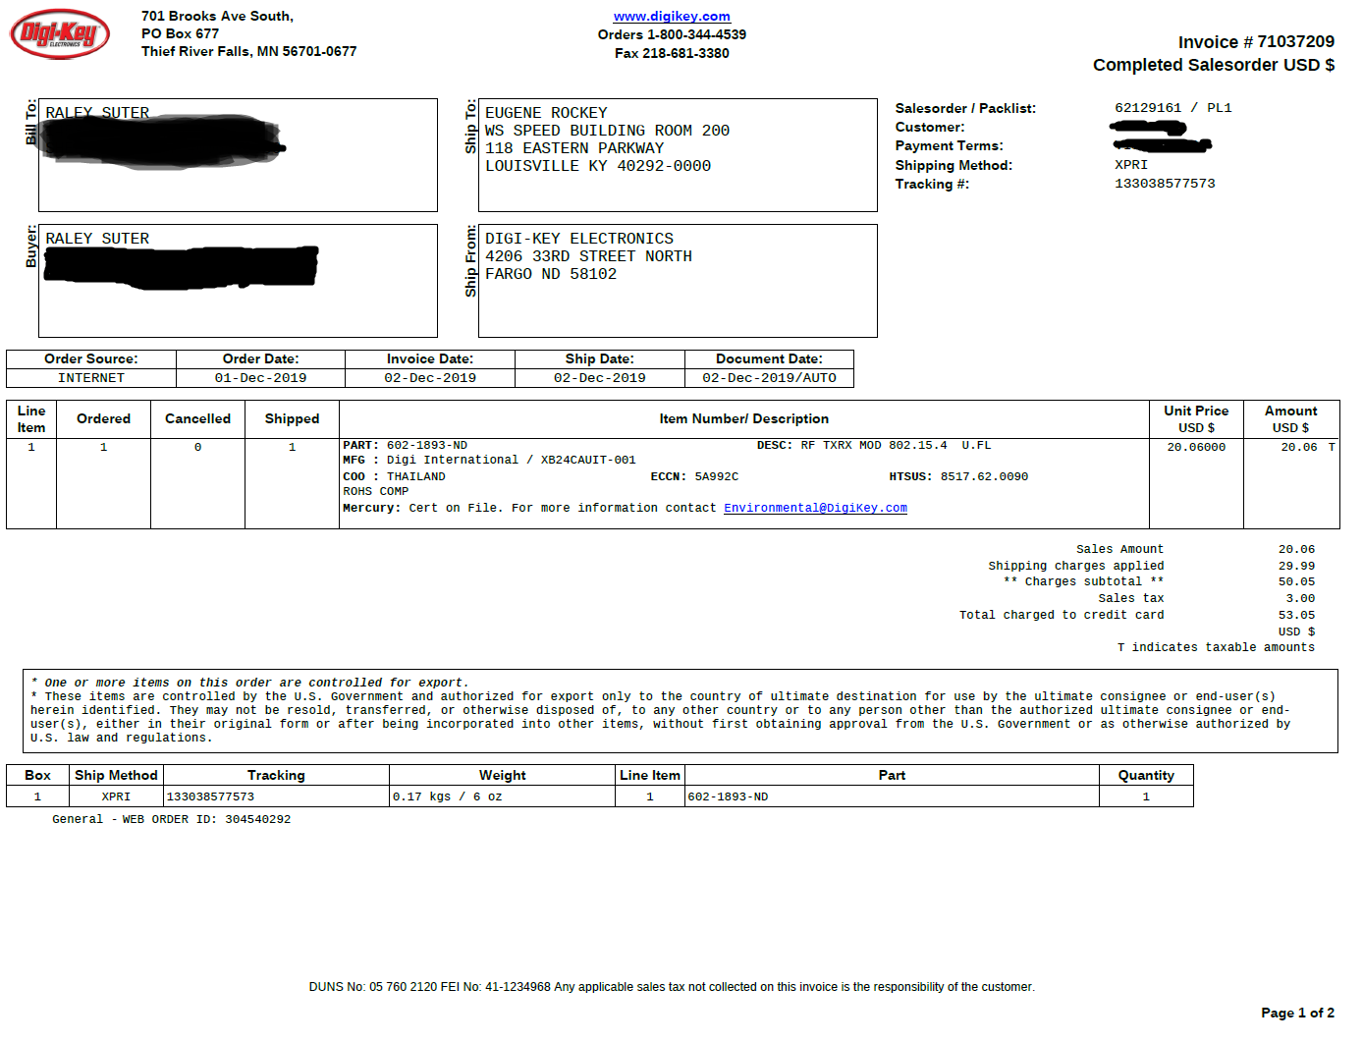

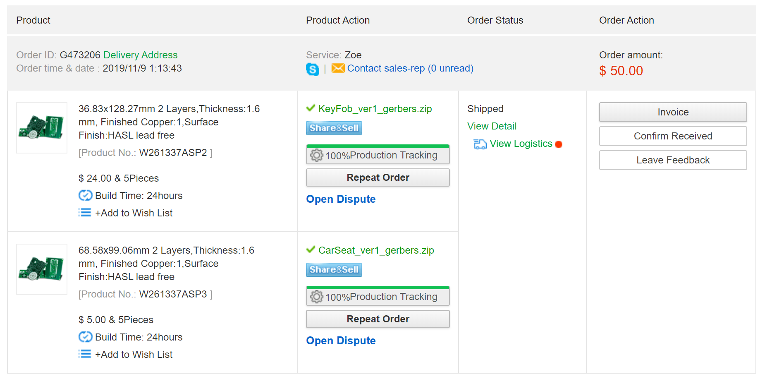

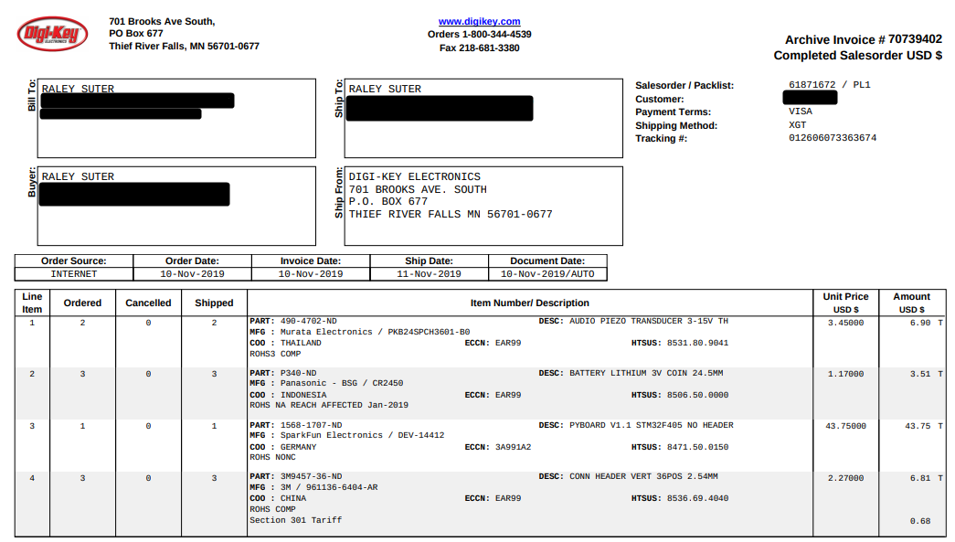

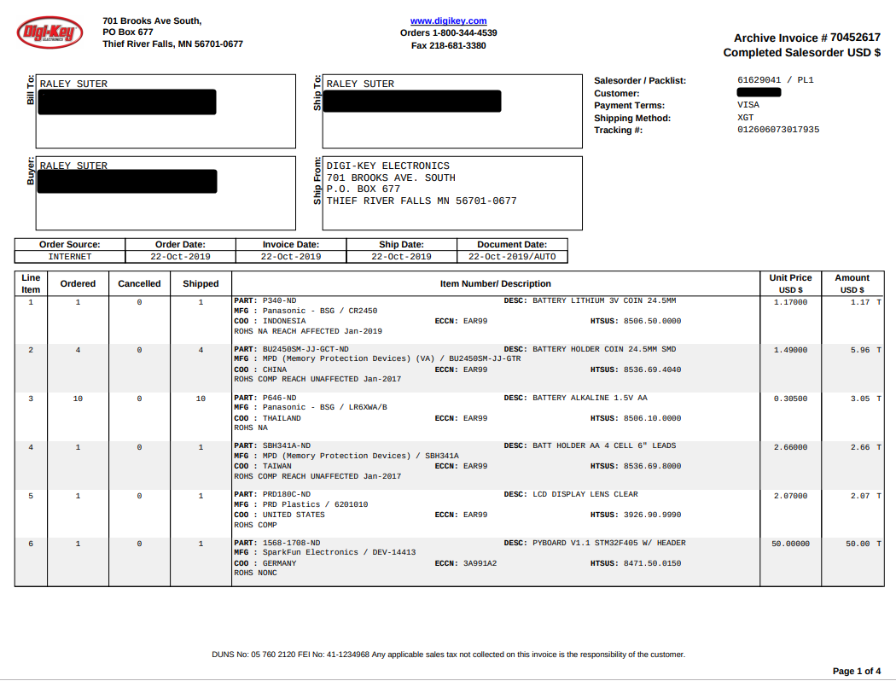

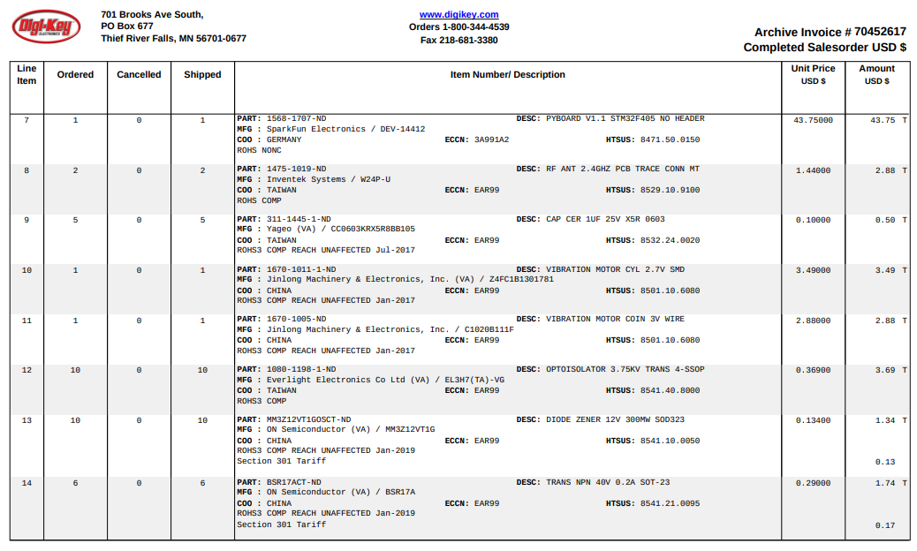

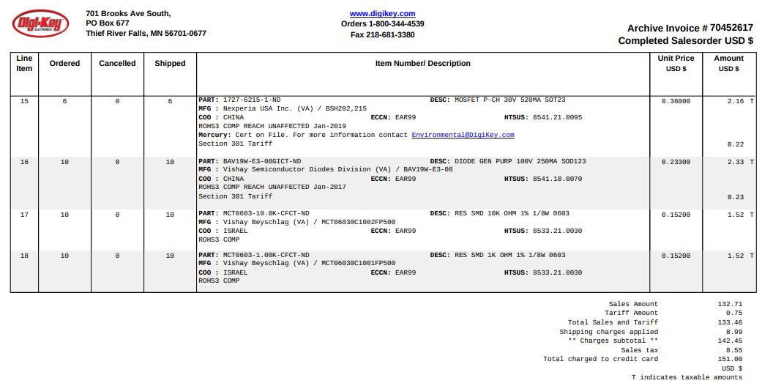

Any remaining purchase orders are in the possession of the project sponsor.

## APPENDIX H: Material Documentation and Reconciliation

|  |  |  |  |  |  |
| --- | --- | --- | --- | --- | --- |
| **Parts Ordered List** | |  |  |  |  |
| **Quantity** | **Name** | **Manufacturer** | **Manufacturer Part Number** | **Distributor Part Number** | **Distributor** |
| 7 | Coin Battery | Panasonic - BSG | CR2450 | P340-ND | Digikey |
| 4 | Coin Battery Holder | MPD | BU2450SM-JJ-GTR | BU2450SM-JJ-GCT-ND | Digikey |
| 10 | AA Battery | Panasonic - BSG | LR6XWA/B | P646-ND | Digikey |
| 1 | AA Battery Holder | MPD | SBH341A | SBH341A-ND | Digikey |
| 1 | Diffuser Lens | PRD Plastics | 6201010 | PRD180C-ND | Digikey |
| 1 | pyboard with headers | SparkFun Electronics | DEV-14413 | 1568-1708-ND | Digikey |
| 2 | pyboard | SparkFun Electronics | DEV-14412 | 1568-1707-ND | Digikey |
| 2 | Telemetry Antenna | Inventek Systems | W24P-U | 1475-1019-ND | Digikey |
| 2 | Buzzer | Murata | PKB24SPCH3601-B0 | 490-4702-ND | Digikey |
| 5 | 1µF capacitor | Yageo | CC0603KRX5R8BB105 | 311-1445-1-ND | Digikey |
| ~~1~~ | ~~Cylinder Vibration Motor~~ | ~~Jinlong~~ | ~~Z4FC1B1301781~~ | ~~1670-1011-1-ND~~ | ~~Digikey~~ |
| 1 | Coin Vibration Motor | Jinlong | C1020B111F | 1670-1005-ND | Digikey |
| 10 | OptoCoupler | Everlight Electronics | EL3H7(TA)-VG | 1080-1198-1-ND | Digikey |
| 10 | Zener Diode | ON Semiconductor | MM3Z12VT1G | MM3Z12VT1GOSCT-ND | Digikey |
| 6 | BJT | ON Semiconductor | BSR17A | BSR17ACT-ND | Digikey |
| 6 | MOSFET | Nexperia USA Inc. | BSH202,215 | 1727-6215-1-ND | Digikey |
| 10 | Diode | Vishay | BAV19W-E3-08 | BAV19W-E3-08GICT-ND | Digikey |
| 10 | 10K Resistor | Vishay | MCT06030C1002FP500 | MCT0603-10.0K-CFCT-ND | Digikey |
| 10 | 1K Resistor | Vishay | MCT06030C1001FP500 | MCT0603-1.00K-CFCT-ND | Digikey |
| 3 | Male to Male Headers | 3M | 3M9457-36-ND | 961136-6404-AR | Digikey |
| ~~1~~ | ~~Replacement Telemetry Board~~ | ~~SparkFun Electronics~~ | ~~XB24CAUIT-001~~ | ~~602-1893-ND~~ | ~~Digikey~~ |
| 1 | #6-32 x 1/4 machine screw | - | 819481 | 653590 | Home Depot |
| 1 | #6-32 x 3/4 machine screw | Everbilt | 813461 | 460428 | Home Depot |
| 2 | GPS Breakout | 4279 | Adafruit | 4279 | Adafruit |
| 2 | GPS Antenna | S66 | Sixfab | S66 | Sixfab |
| 2 | Telemetry Board | SparkFun Electronics | XB3-24Z8UT-J | 888-XB3-24Z8UT-J | Mouser |
| 1 | Telemetry headers | Samtec | SMM-110-02-SM-S-TR | 200-SMM11002SMS | Mouser |
| 1 | M3 x 6mm screw bolt | uxcell | a15070200ux0064 | B012TE12CY | Amazon |
| 1 | M3 Square Nuts | Honbay | M3-SQUARE-NUTS-100PCS | B06XPFLNBS | Amazon |
| 1 | Xbee Xplorer USB | SparkFun Electronics | WRL-11697 | B008O92TZS | Amazon |
| 1 | CarSeat PCB | PCBWay | W261337ASP2 | - | PCBWay |
| 1 | KeyFob PCB | PCBWay | W261337ASP3 | - | PCBWay |

|  |  |  |  |
| --- | --- | --- | --- |
|  |  |  |  |
| **Unit Price** | **Extended Price** | **Data Sheet URL** | **Distributor URL** |
| $1.17 | $8.19 | - | <https://www.digikey.com/product-detail/en/panasonic-bsg/CR2450/P340-ND/447508> |
| $1.49 | $5.96 | - | <https://www.digikey.com/product-detail/en/mpd-memory-protection-devices/BU2450SM-JJ-GTR/BU2450SM-JJ-GCT-ND/3028728> |
| $0.37 | $3.70 | - | <https://www.digikey.com/product-detail/en/panasonic-bsg/LR6XWA-B/P646-ND/2043737> |
| $2.66 | $2.66 | - | <https://www.digikey.com/product-detail/en/mpd-memory-protection-devices/SBH341A/SBH341A-ND/2439569> |
| $2.07 | $2.07 | - | <https://www.digikey.com/product-detail/en/prd-plastics/6201010/PRD180C-ND/151885> |
| $50.00 | $50.00 | <https://media.digikey.com/pdf/Data%20Sheets/Sparkfun%20PDFs/Pyboard_Hookup_Guide_Web.pdf> | <https://www.digikey.com/products/en?mpart=DEV-14413&v=1568> |
| $43.75 | $87.50 | <https://media.digikey.com/pdf/Data%20Sheets/Sparkfun%20PDFs/Pyboard_Hookup_Guide_Web.pdf> | <https://www.digikey.com/products/en?mpart=DEV-14412&v=1568> |
| $1.44 | $2.88 | - | <https://www.digikey.com/product-detail/en/inventek-systems/W24P-U/1475-1019-ND/4488778&?gclid=Cj0KCQjw3JXtBRC8ARIsAEBHg4mon2n44LSwj1rYQXSZ0LBEK25AY_x-V355A7lJvJs1hhMA5SFXqX4aApGwEALw_wcB> |
| $3.45 | $6.90 | - | <https://www.digikey.com/products/en?keywords=PKB24SPCH3601-B0> |
| $0.10 | $0.50 | - | <https://www.digikey.com/product-detail/en/yageo/CC0603KRX5R8BB105/311-1445-1-ND/2833751?utm_adgroup=Capacitors&slid=&gclid=Cj0KCQjwoqDtBRD-ARIsAL4pviBbDffO_WsLV8uWxDqxLbvMJmeOZOyEhDWdQgNOYs1p4yrQD8FP-M0aAiqdEALw_wcB> |
| ~~$3.49~~ | ~~$3.49~~ | - | <https://www.digikey.com/product-detail/en/jinlong-machinery-electronics-inc/Z4FC1B1301781/1670-1011-1-ND/6009936> |
| $2.88 | $2.88 | - | <https://www.digikey.com/product-detail/en/jinlong-machinery-electronics-inc/C1020B111F/1670-1005-ND/6009910> |
| $0.51 | $5.10 | - | <https://www.digikey.com/product-detail/en/everlight-electronics-co-ltd/EL3H7-TA-VG/1080-1198-1-ND/2675932> |
| $0.13 | $1.30 | - | <https://www.digikey.com/product-detail/en/on-semiconductor/MM3Z12VT1G/MM3Z12VT1GOSCT-ND/661695> |
| $0.29 | $1.74 | - | <https://www.digikey.com/product-detail/en/on-semiconductor/BSR17A/BSR17ACT-ND/2094410> |
| $0.36 | $2.16 | - | <https://www.digikey.com/product-detail/en/nexperia-usa-inc/BSH202215/1727-6215-1-ND/2762716> |
| $0.28 | $2.80 | - | <https://www.digikey.com/product-detail/en/vishay-semiconductor-diodes-division/BAV19W-E3-08/BAV19W-E3-08GICT-ND/6946437> |
| $0.18 | $1.80 | - | <https://www.digikey.com/products/en?keywords=MCT0603-10.0K-CFCT-ND> |
| $0.18 | $1.80 | - | <https://www.digikey.com/products/en?keywords=MCT0603-1.00K-CFCT-ND> |
| $2.27 | $6.81 | - | <https://www.digikey.com/product-detail/en/3m/961136-6404-AR/3M9457-36-ND/2071498> |
| ~~$20.06~~ | ~~$20.06~~ | <https://www.digi.com/resources/documentation/digidocs/pdfs/90001500.pdf> | <https://www.digikey.com/products/en?keywords=602-1893-ND> |
| $1.18 | $1.18 | - | <https://www.homedepot.com/p/6-32-x-1-4-in-Combo-Pan-Head-Zinc-Plated-Machine-Screw-8-Pack-819481/204282761> |
| $0.98 | $0.98 | - | <https://www.homedepot.com/p/Everbilt-6-32-x-3-4-in-Phillips-Flat-Head-Zinc-Plated-Machine-Screw-8-Pack-813461/204274659?keyword=460428&semanticToken=20330000111_20191204221509297466_3r31+20330000111+%3E++cnn%3A%7B0%3A0%7D+cnr%3A%7B7%3A0%7D+cnd%3A%7B4%3A0%7D+cne%3A%7B8%3A0%7D+cnb%3A%7B9%3A0%7D+cns%3A%7B5%3A0%7D+cnx%3A%7B3%3A0%7D+st%3A%7B460428%7D%3Ast+oos%3A%7B0%3A1%7D+dln%3A%7B562734%7D+qu%3A%7B460428%7D%3Aqu> |
| $39.95 | $79.90 | - | <https://www.adafruit.com/product/746> |
| $12.60 | $25.20 | - | <https://sixfab.com/product/internal-active-gps-antenna-15db-25mm-x-25mm-u-fl-plug/?utm_medium=ppc&utm_campaign=US+Smart+Shopping&utm_term=&utm_source=adwords&hsa_src=u&hsa_net=adwords&hsa_kw=&hsa_tgt=pla-293946777986&hsa_ad=355845382964&hsa_grp=78850140224&hsa_mt=&hsa_acc=6308888758&hsa_ver=3&hsa_cam=2037647658&gclid=Cj0KCQjw3JXtBRC8ARIsAEBHg4mSzIN8WAyl86ccdp28ZW-_khK69C30LfbSgaW_Ql739PRHlUxMxKoaArKoEALw_wcB> |
| $20.06 | $40.12 | <https://www.sparkfun.com/datasheets/Wireless/Zigbee/XBee-Datasheet.pdf> | <https://www.mouser.com/ProductDetail/Digi-International/XB3-24Z8UT-J?qs=W0yvOO0ixfEt5vZ7r3XYgQ%3D%3D&utm_source=eciaauthorized&utm_medium=aggregator&utm_campaign=XB3-24Z8UT-J&utm_term=XB3-24Z8UT-J&utm_content=Digi-International> |
| $3.15 | $3.15 | - | <https://www.mouser.com/ProductDetail/Samtec/SMM-110-02-SM-S?qs=Cqqh%252bS766wn1Ca7JqumYVw%3D%3D&gclid=Cj0KCQjwoqDtBRD-ARIsAL4pviDild2DkypvC6CtYJLILUMT9pOE47m-TNcfhIW2u6spdJLSeFySuawaAk59EALw_wcB> |
| $5.61 | $5.61 | - | <https://www.amazon.com/gp/product/B012TE12CY/ref=ppx_od_dt_b_asin_title_s01?ie=UTF8&psc=1> |
| $6.99 | $6.99 | - | <https://www.amazon.com/gp/product/B06XPFLNBS/ref=ppx_od_dt_b_asin_title_s03?ie=UTF8&psc=1> |
| $28.94 | $28.94 | <https://www.sparkfun.com/products/11697> | <https://www.amazon.com/dp/B008O92TZS/ref=cm_sw_r_cp_api_i_aSg6Db83ADGDX> |
| $5.00 | $5.00 | - | pcbway.com |
| $24.00 | $24.00 | - | pcbway.com |

### Single Product Parts

|  |  |  |  |  |  |
| --- | --- | --- | --- | --- | --- |
| **Material for One Unit** | |  |  |  |  |
| **Quantity** | **Name** | **Manufacturer** | **Manufacturer Part Number** | **Distributor Part Number** | **Distributor** |
| **Carseat Module (x1)** | |  |  |  |  |
| 4 | AA Battery | Panasonic - BSG | LR6XWA/B | P646-ND | Digikey |
| 1 | AA Battery Holder | MPD | SBH341A | SBH341A-ND | Digikey |
| 1 | pyboard | SparkFun Electronics | DEV-14412 | 1568-1707-ND | Digikey |
| 1 | Telemetry Antenna | Inventek Systems | W24P-U | 1475-1019-ND | Digikey |
| 1 | Buzzer | Murata | PKB24SPCH3601-B0 | 490-4702-ND | Digikey |
| 1 | 1µF capacitor | Yageo | CC0603KRX5R8BB105 | 311-1445-1-ND | Digikey |
| 1 | Coin Vibration Motor | Jinlong | C1020B111F | 1670-1005-ND | Digikey |
| 1 | OptoCoupler | Everlight Electronics | EL3H7(TA)-VG | 1080-1198-1-ND | Digikey |
| 2 | Zener Diode | ON Semiconductor | MM3Z12VT1G | MM3Z12VT1GOSCT-ND | Digikey |
| 1 | BJT | ON Semiconductor | BSR17A | BSR17ACT-ND | Digikey |
| 1 | MOSFET | Nexperia USA Inc. | BSH202,215 | 1727-6215-1-ND | Digikey |
| 1 | Diode | Vishay | BAV19W-E3-08 | BAV19W-E3-08GICT-ND | Digikey |
| 2 | 10K Resistor | Vishay | MCT06030C1002FP500 | MCT0603-10.0K-CFCT-ND | Digikey |
| 2 | 1K Resistor | Vishay | MCT06030C1001FP500 | MCT0603-1.00K-CFCT-ND | Digikey |
| 1 | Male to Male Headers | 3M | 3M9457-36-ND | 961136-6404-AR | Digikey |
| 1 | GPS Breakout | 4279 | Adafruit | 4279 | Adafruit |
| 1 | GPS Antenna | S66 | Sixfab | S66 | Sixfab |
| 1 | Telemetry Board | SparkFun Electronics | XB3-24Z8UT-J | 888-XB3-24Z8UT-J | Mouser |
| 1 | Telemetry headers | Samtec | SMM-110-02-SM-S-TR | 200-SMM11002SMS | Mouser |
| 1 | CarSeat PCB | PCBWay | W261337ASP2 | - | PCBWay |

|  |  |  |  |
| --- | --- | --- | --- |
|  |  |  |  |
| **Unit Price** | **Extended Price** | **Data Sheet URL** | **Distributor URL** |
|  |  |  |  |
| $0.37 | $1.48 | - | <https://www.digikey.com/product-detail/en/panasonic-bsg/LR6XWA-B/P646-ND/2043737> |
| $2.66 | $2.66 | - | <https://www.digikey.com/product-detail/en/mpd-memory-protection-devices/SBH341A/SBH341A-ND/2439569> |
| $43.75 | $43.75 | <https://media.digikey.com/pdf/Data%20Sheets/Sparkfun%20PDFs/Pyboard_Hookup_Guide_Web.pdf> | <https://www.digikey.com/products/en?mpart=DEV-14412&v=1568> |
| $1.44 | $1.44 | - | <https://www.digikey.com/product-detail/en/inventek-systems/W24P-U/1475-1019-ND/4488778&?gclid=Cj0KCQjw3JXtBRC8ARIsAEBHg4mon2n44LSwj1rYQXSZ0LBEK25AY_x-V355A7lJvJs1hhMA5SFXqX4aApGwEALw_wcB> |
| $3.45 | $3.45 | - | <https://www.digikey.com/products/en?keywords=PKB24SPCH3601-B0> |
| $0.10 | $0.10 | - | <https://www.digikey.com/product-detail/en/yageo/CC0603KRX5R8BB105/311-1445-1-ND/2833751?utm_adgroup=Capacitors&slid=&gclid=Cj0KCQjwoqDtBRD-ARIsAL4pviBbDffO_WsLV8uWxDqxLbvMJmeOZOyEhDWdQgNOYs1p4yrQD8FP-M0aAiqdEALw_wcB> |
| $2.88 | $2.88 | - | <https://www.digikey.com/product-detail/en/jinlong-machinery-electronics-inc/C1020B111F/1670-1005-ND/6009910> |
| $0.51 | $0.51 | - | <https://www.digikey.com/product-detail/en/everlight-electronics-co-ltd/EL3H7-TA-VG/1080-1198-1-ND/2675932> |
| $0.13 | $0.26 | - | <https://www.digikey.com/product-detail/en/on-semiconductor/MM3Z12VT1G/MM3Z12VT1GOSCT-ND/661695> |
| $0.29 | $0.29 | - | <https://www.digikey.com/product-detail/en/on-semiconductor/BSR17A/BSR17ACT-ND/2094410> |
| $0.36 | $0.36 | - | <https://www.digikey.com/product-detail/en/nexperia-usa-inc/BSH202215/1727-6215-1-ND/2762716> |
| $0.28 | $0.28 | - | <https://www.digikey.com/product-detail/en/vishay-semiconductor-diodes-division/BAV19W-E3-08/BAV19W-E3-08GICT-ND/6946437> |
| $0.18 | $0.36 | - | <https://www.digikey.com/products/en?keywords=MCT0603-10.0K-CFCT-ND> |
| $0.18 | $0.36 | - | <https://www.digikey.com/products/en?keywords=MCT0603-1.00K-CFCT-ND> |
| $2.27 | $2.27 | - | <https://www.digikey.com/product-detail/en/3m/961136-6404-AR/3M9457-36-ND/2071498> |
| $39.95 | $39.95 | - | <https://www.adafruit.com/product/746> |
| $12.60 | $12.60 | - | <https://sixfab.com/product/internal-active-gps-antenna-15db-25mm-x-25mm-u-fl-plug/?utm_medium=ppc&utm_campaign=US+Smart+Shopping&utm_term=&utm_source=adwords&hsa_src=u&hsa_net=adwords&hsa_kw=&hsa_tgt=pla-293946777986&hsa_ad=355845382964&hsa_grp=78850140224&hsa_mt=&hsa_acc=6308888758&hsa_ver=3&hsa_cam=2037647658&gclid=Cj0KCQjw3JXtBRC8ARIsAEBHg4mSzIN8WAyl86ccdp28ZW-_khK69C30LfbSgaW_Ql739PRHlUxMxKoaArKoEALw_wcB> |
| $20.06 | $20.06 | <https://www.sparkfun.com/datasheets/Wireless/Zigbee/XBee-Datasheet.pdf> | <https://www.mouser.com/ProductDetail/Digi-International/XB3-24Z8UT-J?qs=W0yvOO0ixfEt5vZ7r3XYgQ%3D%3D&utm_source=eciaauthorized&utm_medium=aggregator&utm_campaign=XB3-24Z8UT-J&utm_term=XB3-24Z8UT-J&utm_content=Digi-International> |
| $3.15 | $3.15 | - | <https://www.mouser.com/ProductDetail/Samtec/SMM-110-02-SM-S?qs=Cqqh%252bS766wn1Ca7JqumYVw%3D%3D&gclid=Cj0KCQjwoqDtBRD-ARIsAL4pviDild2DkypvC6CtYJLILUMT9pOE47m-TNcfhIW2u6spdJLSeFySuawaAk59EALw_wcB> |
| $5.00 | $5.00 | - | pcbway.com |

|  |  |  |  |  |  |
| --- | --- | --- | --- | --- | --- |
| **Keyfob Module (x1)** | |  |  |  |  |
| 1 | pyboard | SparkFun Electronics | DEV-14412 | 1568-1707-ND | Digikey |
| 1 | Telemetry Antenna | Inventek Systems | W24P-U | 1475-1019-ND | Digikey |
| 1 | Buzzer | Murata | PKB24SPCH3601-B0 | 490-4702-ND | Digikey |
| 1 | 1µF capacitor | Yageo | CC0603KRX5R8BB105 | 311-1445-1-ND | Digikey |
| 1 | Coin Vibration Motor | Jinlong | C1020B111F | 1670-1005-ND | Digikey |
| 1 | OptoCoupler | Everlight Electronics | EL3H7(TA)-VG | 1080-1198-1-ND | Digikey |
| 2 | Zener Diode | ON Semiconductor | MM3Z12VT1G | MM3Z12VT1GOSCT-ND | Digikey |
| 1 | BJT | ON Semiconductor | BSR17A | BSR17ACT-ND | Digikey |
| 1 | MOSFET | Nexperia USA Inc. | BSH202,215 | 1727-6215-1-ND | Digikey |
| 1 | Diode | Vishay | BAV19W-E3-08 | BAV19W-E3-08GICT-ND | Digikey |
| 2 | 10K Resistor | Vishay | MCT06030C1002FP500 | MCT0603-10.0K-CFCT-ND | Digikey |
| 2 | 1K Resistor | Vishay | MCT06030C1001FP500 | MCT0603-1.00K-CFCT-ND | Digikey |
| 1 | Male to Male Headers | 3M | 3M9457-36-ND | 961136-6404-AR | Digikey |
| 1 | GPS Breakout | 4279 | Adafruit | 4279 | Adafruit |
| 1 | GPS Antenna | S66 | Sixfab | S66 | Sixfab |
| 1 | Telemetry Board | SparkFun Electronics | XB3-24Z8UT-J | 888-XB3-24Z8UT-J | Mouser |
| 1 | Telemetry headers | Samtec | SMM-110-02-SM-S-TR | 200-SMM11002SMS | Mouser |
| 2 | Coin Battery | Panasonic - BSG | CR2450 | P340-ND | Digikey |
| 2 | Coin Battery Holder | MPD | BU2450SM-JJ-GTR | BU2450SM-JJ-GCT-ND | Digikey |
| 1 | KeyFob PCB | PCBWay | W261337ASP3 | - | PCBWay |

|  |  |  |  |
| --- | --- | --- | --- |
| $43.75 | $43.75 | <https://media.digikey.com/pdf/Data%20Sheets/Sparkfun%20PDFs/Pyboard_Hookup_Guide_Web.pdf> | <https://www.digikey.com/products/en?mpart=DEV-14412&v=1568> |
| $1.44 | $1.44 | - | <https://www.digikey.com/product-detail/en/inventek-systems/W24P-U/1475-1019-ND/4488778&?gclid=Cj0KCQjw3JXtBRC8ARIsAEBHg4mon2n44LSwj1rYQXSZ0LBEK25AY_x-V355A7lJvJs1hhMA5SFXqX4aApGwEALw_wcB> |
| $3.45 | $3.45 | - | <https://www.digikey.com/products/en?keywords=PKB24SPCH3601-B0> |
| $0.10 | $0.10 | - | <https://www.digikey.com/product-detail/en/yageo/CC0603KRX5R8BB105/311-1445-1-ND/2833751?utm_adgroup=Capacitors&slid=&gclid=Cj0KCQjwoqDtBRD-ARIsAL4pviBbDffO_WsLV8uWxDqxLbvMJmeOZOyEhDWdQgNOYs1p4yrQD8FP-M0aAiqdEALw_wcB> |
| $2.88 | $2.88 | - | <https://www.digikey.com/product-detail/en/jinlong-machinery-electronics-inc/C1020B111F/1670-1005-ND/6009910> |
| $0.51 | $0.51 | - | <https://www.digikey.com/product-detail/en/everlight-electronics-co-ltd/EL3H7-TA-VG/1080-1198-1-ND/2675932> |
| $0.13 | $ 0.26 | - | <https://www.digikey.com/product-detail/en/on-semiconductor/MM3Z12VT1G/MM3Z12VT1GOSCT-ND/661695> |
| $0.29 | $0.29 | - | <https://www.digikey.com/product-detail/en/on-semiconductor/BSR17A/BSR17ACT-ND/2094410> |
| $0.36 | $0.36 | - | <https://www.digikey.com/product-detail/en/nexperia-usa-inc/BSH202215/1727-6215-1-ND/2762716> |
| $0.28 | $0.28 | - | <https://www.digikey.com/product-detail/en/vishay-semiconductor-diodes-division/BAV19W-E3-08/BAV19W-E3-08GICT-ND/6946437> |
| $0.18 | $0.36 | - | <https://www.digikey.com/products/en?keywords=MCT0603-10.0K-CFCT-ND> |
| $0.18 | $0.36 | - | <https://www.digikey.com/products/en?keywords=MCT0603-1.00K-CFCT-ND> |
| $2.27 | $2.27 | - | <https://www.digikey.com/product-detail/en/3m/961136-6404-AR/3M9457-36-ND/2071498> |
| $39.95 | $39.95 | - | <https://www.adafruit.com/product/746> |
| $12.60 | $12.60 | - | <https://sixfab.com/product/internal-active-gps-antenna-15db-25mm-x-25mm-u-fl-plug/?utm_medium=ppc&utm_campaign=US+Smart+Shopping&utm_term=&utm_source=adwords&hsa_src=u&hsa_net=adwords&hsa_kw=&hsa_tgt=pla-293946777986&hsa_ad=355845382964&hsa_grp=78850140224&hsa_mt=&hsa_acc=6308888758&hsa_ver=3&hsa_cam=2037647658&gclid=Cj0KCQjw3JXtBRC8ARIsAEBHg4mSzIN8WAyl86ccdp28ZW-_khK69C30LfbSgaW_Ql739PRHlUxMxKoaArKoEALw_wcB> |
| $20.06 | $20.06 | <https://www.sparkfun.com/datasheets/Wireless/Zigbee/XBee-Datasheet.pdf> | <https://www.mouser.com/ProductDetail/Digi-International/XB3-24Z8UT-J?qs=W0yvOO0ixfEt5vZ7r3XYgQ%3D%3D&utm_source=eciaauthorized&utm_medium=aggregator&utm_campaign=XB3-24Z8UT-J&utm_term=XB3-24Z8UT-J&utm_content=Digi-International> |
| $3.15 | $3.15 | - | <https://www.mouser.com/ProductDetail/Samtec/SMM-110-02-SM-S?qs=Cqqh%252bS766wn1Ca7JqumYVw%3D%3D&gclid=Cj0KCQjwoqDtBRD-ARIsAL4pviDild2DkypvC6CtYJLILUMT9pOE47m-TNcfhIW2u6spdJLSeFySuawaAk59EALw_wcB> |
| $1.17 | $2.34 | - | <https://www.digikey.com/product-detail/en/panasonic-bsg/CR2450/P340-ND/447508> |
| $1.49 | $2.98 | - | <https://www.digikey.com/product-detail/en/mpd-memory-protection-devices/BU2450SM-JJ-GTR/BU2450SM-JJ-GCT-ND/3028728> |
| $24.00 | $24.00 | - | pcbway.com |

### Overhead Parts List:

|  |  |  |  |  |  |  |
| --- | --- | --- | --- | --- | --- | --- |
|  | **Overhead Parts** | |  |  |  |  |
| **Item** | **Quantity** | **Name** | **Manufacturer** | **Manufacturer Part Number** | **Distributor Part Number** | **Distributor** |
| 1 | 1 | Diffuser Lens | PRD Plastics | 6201010 | PRD180C-ND | Digikey |
| 2 | 1 | Xbee Xplorer USB | SparkFun Electronics | WRL-11697 | B008O92TZS | Amazon |
| 3 | 1 | #6-32 x 1/4 machine screw | - | 819481 | 653590 | Home Depot |
| 4 | 1 | #6-32 x 3/4 machine screw | Everbilt | 813461 | 460428 | Home Depot |
| 5 | 1 | M3 x 6mm screw bolt | uxcell | a15070200ux0064 | B012TE12CY | Amazon |
| 6 | 1 | M3 Square Nuts | Honbay | M3-SQUARE-NUTS-100PCS | B06XPFLNBS | Amazon |

|  |  |  |  |  |
| --- | --- | --- | --- | --- |
|  |  |  |  |  |
| **Item** | **Unit Price** | **Extended Price** | **Data Sheet URL** | **Distributor URL** |
| 1 | $2.07 | $2.07 | - | <https://www.digikey.com/product-detail/en/prd-plastics/6201010/PRD180C-ND/151885> |
| 2 | $28.94 | $28.94 | <https://www.sparkfun.com/products/11697> | <https://www.amazon.com/dp/B008O92TZS/ref=cm_sw_r_cp_api_i_aSg6Db83ADGDX> |
| 3 | $1.18 | $1.18 | - | <https://www.homedepot.com/p/6-32-x-1-4-in-Combo-Pan-Head-Zinc-Plated-Machine-Screw-8-Pack-819481/204282761> |
| 4 | $0.98 | $0.98 | - | <https://www.homedepot.com/p/Everbilt-6-32-x-3-4-in-Phillips-Flat-Head-Zinc-Plated-Machine-Screw-8-Pack-813461/204274659?keyword=460428&semanticToken=20330000111_20191204221509297466_3r31+20330000111+%3E++cnn%3A%7B0%3A0%7D+cnr%3A%7B7%3A0%7D+cnd%3A%7B4%3A0%7D+cne%3A%7B8%3A0%7D+cnb%3A%7B9%3A0%7D+cns%3A%7B5%3A0%7D+cnx%3A%7B3%3A0%7D+st%3A%7B460428%7D%3Ast+oos%3A%7B0%3A1%7D+dln%3A%7B562734%7D+qu%3A%7B460428%7D%3Aqu> |
| 5 | $5.61 | $5.61 | - | <https://www.amazon.com/gp/product/B012TE12CY/ref=ppx_od_dt_b_asin_title_s01?ie=UTF8&psc=1> |
| 6 | $6.99 | $6.99 | - | <https://www.amazon.com/gp/product/B06XPFLNBS/ref=ppx_od_dt_b_asin_title_s03?ie=UTF8&psc=1> |

## APPENDIX I: SolidWorks Drawings

Appendix J: Schematics

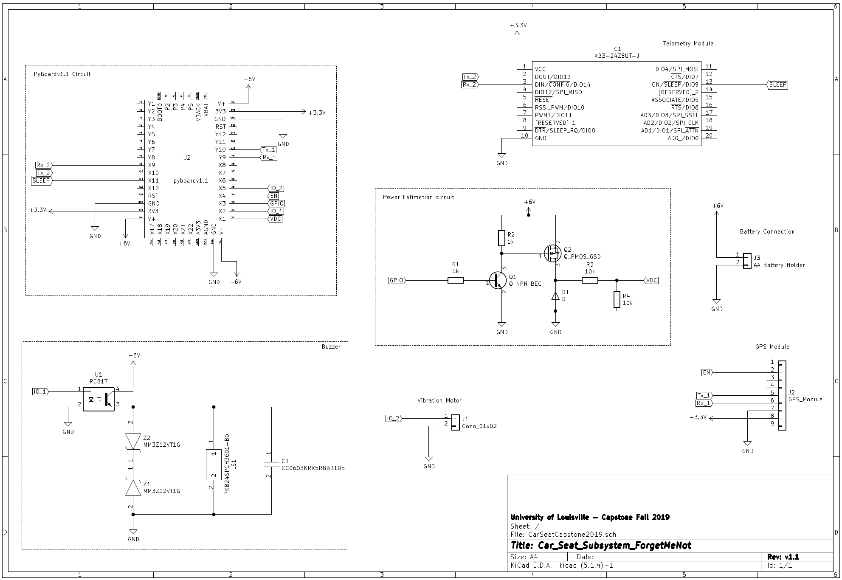

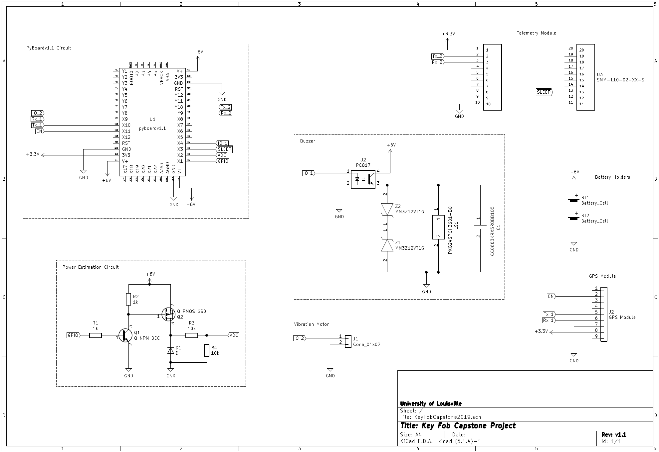

Appendix K: Test Results

|  |  |  |  |  |  |
| --- | --- | --- | --- | --- | --- |
| Tests: | Disarm Button Test | | |  |  |
|  | Run | Pass | Fail | Comments |  |
|  | 1 | X |  |  |  |
|  | 2 | X |  |  |  |
|  | 3 | X |  |  |  |
|  | 4 | X |  | System powered by batteries | |
|  | 5 | X |  |  |  |
|  |  |  |  |  |  |
|  | Snooze Button Test | | |  |  |
|  | Run | Pass | Fail | Comments |  |
|  | 1 | X |  |  |  |
|  | 2 | X |  | 2:02 Minutes | |
|  | 3 | X |  | 1:59 Minutes | |
|  | 4 | X |  | Using Computer to power | |
|  | 5 | X |  | 2:00 Minutes, Using Computer to power | |
|  |  |  |  |  |  |
|  | Sound/Vibration Test | |  |  |  |
|  | Run | Pass | Fail | Comments |  |
|  | 1 | X |  |  |  |
|  | 2 | X |  |  |  |
|  | 3 | X |  |  |  |
|  | 4 | X |  |  |  |
|  | 5 | X |  |  |  |
|  |  |  |  |  |  |
|  | Alarm sounds when connection is lost | | | |  |
|  | Run | Pass | Fail | Comments |  |
|  | 1 | X |  |  |  |
|  | 2 | X |  | Used Computer to Power | |
|  | 3 | X |  | Battery powered and walking away | |
|  | 4 | X |  | Batttery powerd and walking away | |
|  | 5 | X |  | Tested in a Car | |
|  |  |  |  |  |  |
|  | Alarm rearmed when connection found | | | |  |
|  | Run | Pass | Fail | Comments |  |
|  | 1 | X |  | On Computer | |
|  | 2 | X |  | On Computer | |
|  | 3 | X |  | Battery on KeyFob | |
|  | 4 | X |  | Car Test with GPS | |
|  | 5 | X |  | Car Test with GPS | |
|  |  |  |  |  |  |
|  |  |  |  |  |  |